Final Usecase

**PROJECT:** DevOps on Azure Free Tier: CI/CD Deployment of a Containerized “Hello World” App

**Objective:**

This project aims to provide practical experience in cloud infrastructure, containerization, and DevOps automation. It guides the deployment of a basic "Hello World" HTML/CSS web application on Azure Free Tier using Docker and Azure Kubernetes Service (AKS). We will learn to set up essential Azure resources, containerize applications, and implement a CI/CD pipeline using Azure DevOps.

**Architecture Reference: 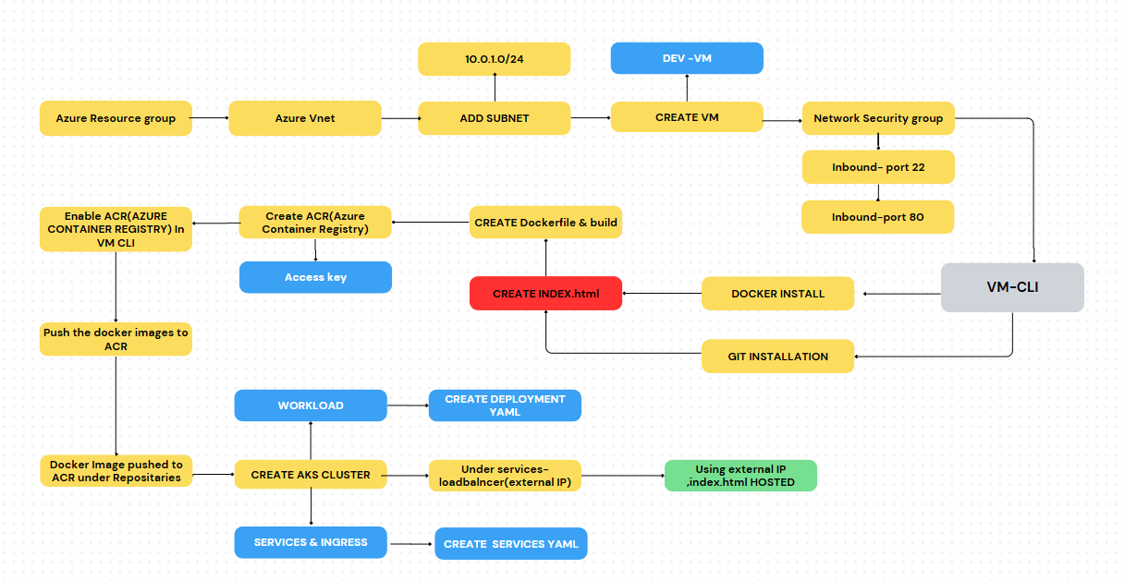SOLUTION:**   
**->** **MANUAL (AZURE)**

**->AUTOMATED (AZURE DEVOPS)**

**Manual Deployment Process: Steps and Challenges**

**This section outlines the traditional, manual steps involved in deploying a web application to a Kubernetes cluster, demonstrating the significant effort required for each change.**

**1. Initial Setup and Application Preparation:**

* **A web application (e.g., an index.html file) is created or provided.**
* **A Dockerfile is prepared to define how to containerize the application, bundling the index.html and other necessary components into a Docker image.**

**2. Containerization and Image Management:**

* **The Docker image is manually built using the Dockerfile.**
* **The newly built Docker image is then manually pushed to a Container Registry (e.g., Azure Container Registry).**

**3. Kubernetes Cluster and Manifests:**

* **An Azure Kubernetes Service (AKS) cluster is provisioned.**
* **Kubernetes manifest files (e.g., deployment.yaml for workload definition and service.yaml for exposing the application) are created to describe how the application should run within the AKS cluster.**

**4. Application Deployment:**

* **The Kubernetes deployment.yaml and service.yaml files are manually applied to the AKS cluster, deploying the containerized application.**
* **The HTML page is made accessible via an external IP address, typically exposed through an Nginx server running within the containers and a Kubernetes LoadBalancer Service.**

**MANUAL::**

Step 1::  
Resource group creation

Named as Dev-RG in Centralus location.

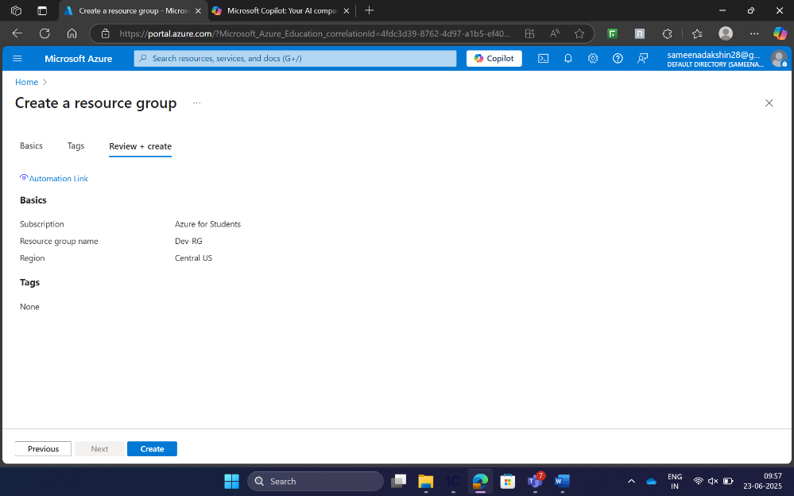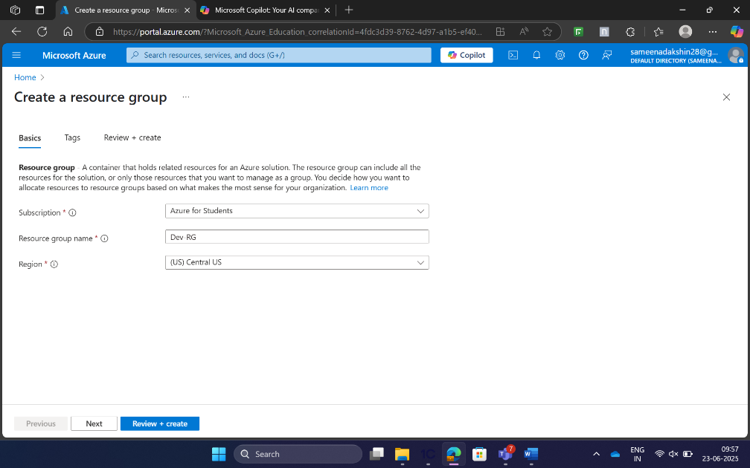

* **Bash Command:** az group create --name Dev-RG --location "Central Us"

Step 2:  
VNet Creation::

* **Name:** Dev-VNet
* **Address Space:** 10.0.0.0/16
* **Purpose:** Enable communication between resources in the Azure environment.
* **Bash Command:** az network vnet create \

--name Dev-VNet \

--resource-group Dev-RG \

--address-prefix 10.0.0.0/16

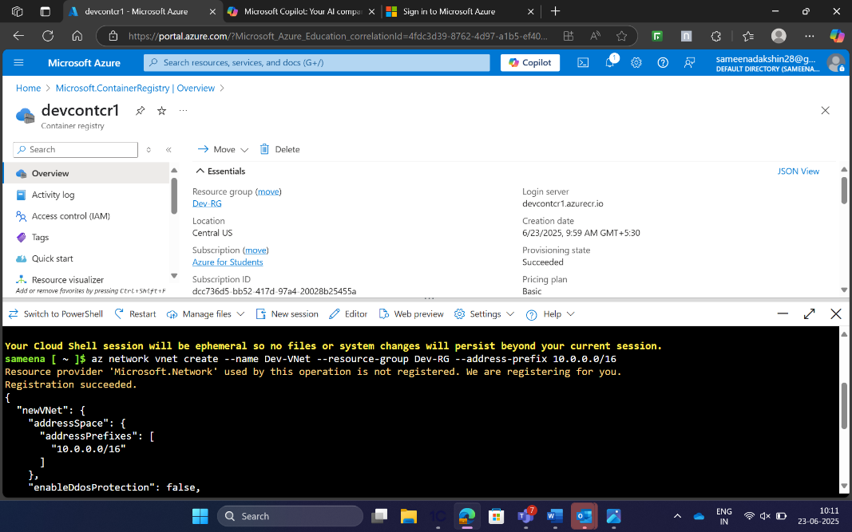  
Create the virtual Network (Vnet**), Name: Dev-VNet with the address space:** **10.0.0.0/16 which is used for the communication between the resources in the Azure Environment.**

Step3::

**. Subnet**

* **Name:** Dev-Subnet
* **Address Range:** 10.0.1.0/24
* **Purpose:** Assign IP addresses for resources inside the VNet.
* **Bash Command:** az network vnet subnet create \

--vnet-name Dev-VNet \

--resource-group Dev-RG \

--name Dev-Subnet \

--address-prefix 10.0.1.0/24

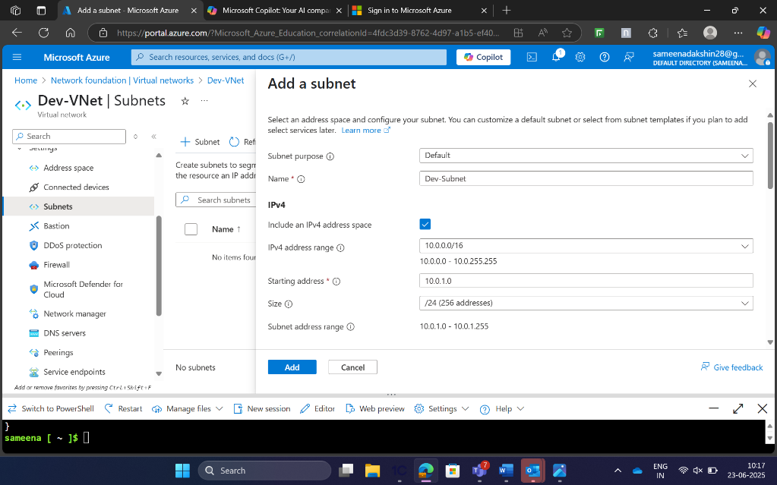

In this step, we need to add **the SUBNET,with** the **name:Dev-Subnet** with the address range **:** 10.0.1.0/24 which is used to assaign ip address for the resources in the VNet

Step 4::

Storage Account::

**Storage Account**

* **Name:** devstorage<uniqueid> (e.g., devstorage12345)
* **Location:** East US
* **SKU:** Standard_LRS
* **Purpose:** Store logs and application-related data.
* **Bash Command:** az storage account create \

--name devstorage12345 \

--resource-group DevEnvironment-RG \

--location "East US" \

--sku Standard_LRS \

--kind StorageV2 \

--tags Project=DevEnvironment Owner=azure-dev-user

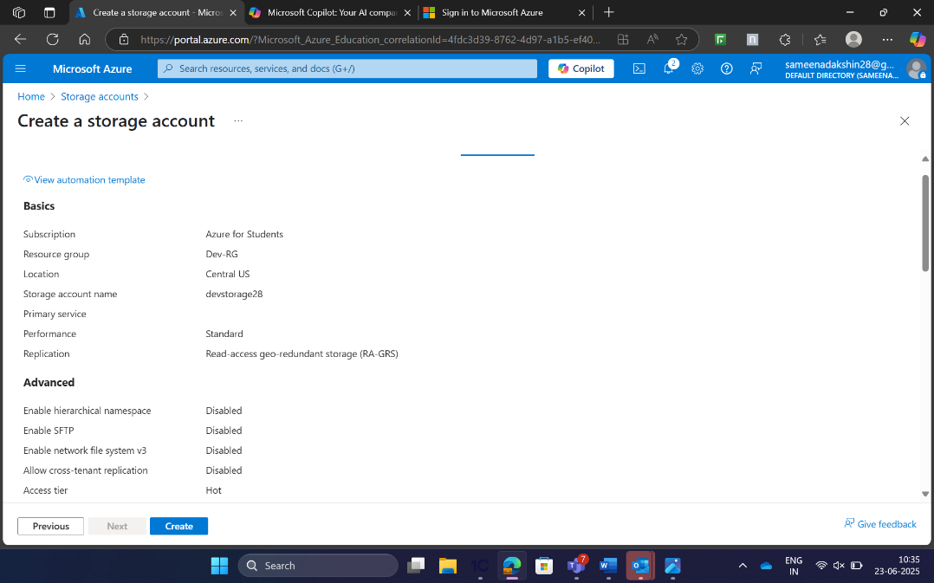  
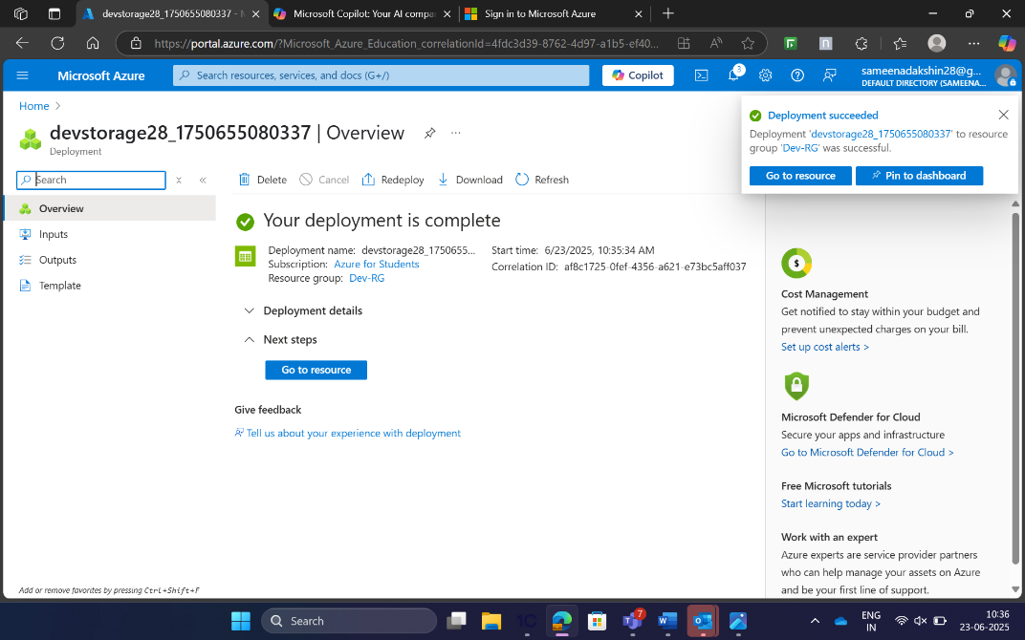

Step 5::

Virtual Machine

* az vm create \

--resource-group Dev-RG \

--name Dev-VM \

--image UbuntuLTS \

--size Standard_B1s \

--admin-username azure-dev-user \

--generate-ssh-keys \

--vnet-name Dev-VNet \

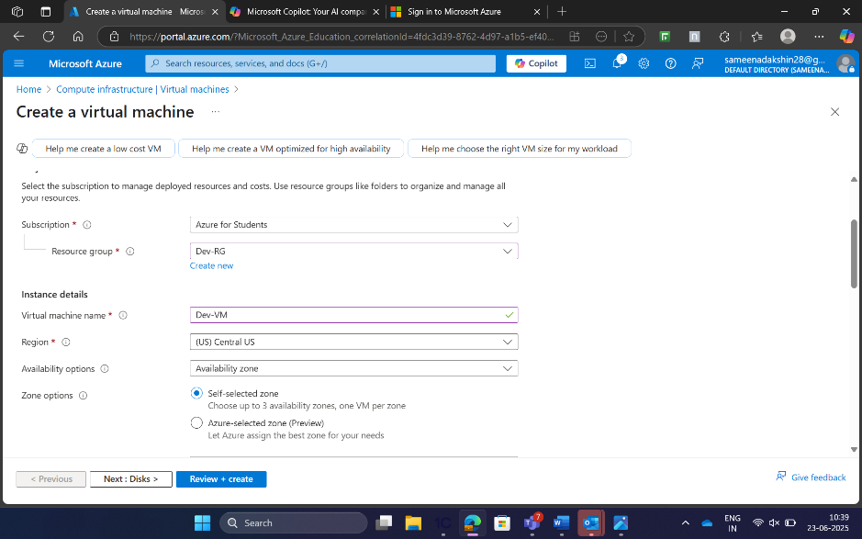

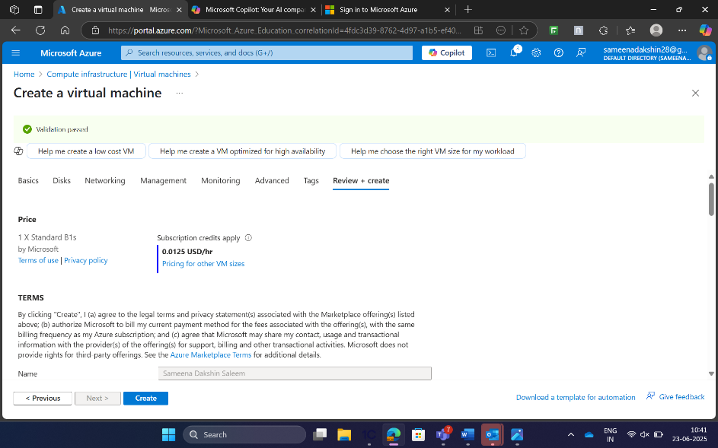

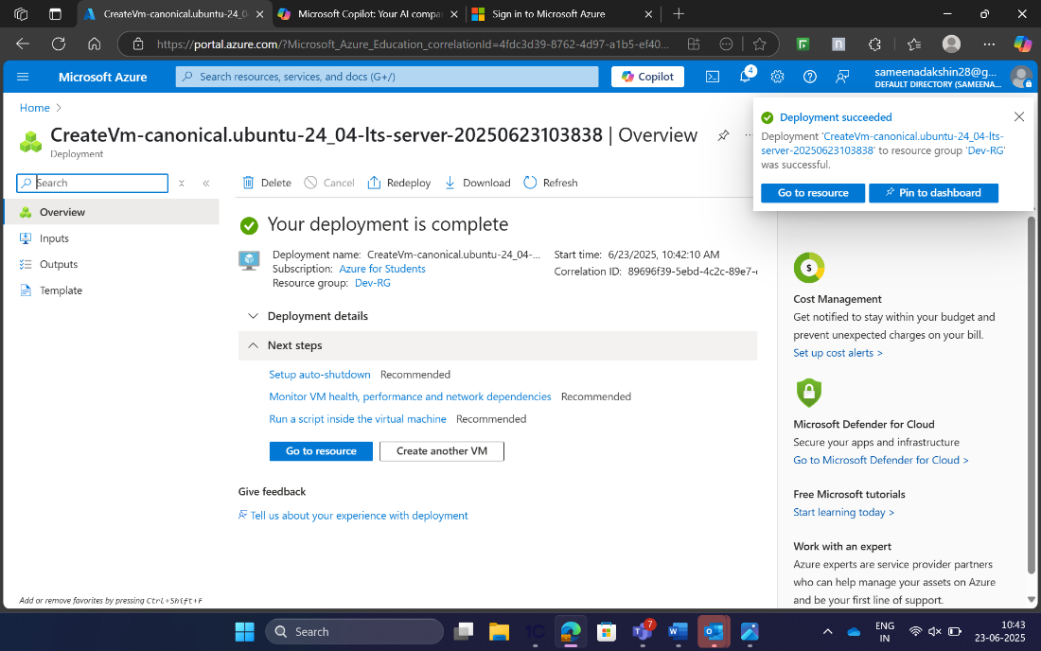

STEP 6:

Network security group:

• Name: Dev-NSG

• Rules: Allow HTTP traffic on port 80 and SSH traffic on port 22.

• Bash Command to Create NSG: az network nsg create --resource-group Dev-RG --name Dev-NSG

Command to Add Rules: az network nsg rule create \

--resource-group Dev-RG \

--nsg-name Dev-NSG \

--name Allow-HTTP \

--priority 100 \

--direction Inbound \

--access Allow \

--protocol Tcp \

--destination-port-ranges 80

az network nsg rule create \

--resource-group Dev-RG \

--nsg-name Dev-NSG \

--name Allow-SSH \

--priority 110 \

--direction Inbound \

--access Allow \

--protocol Tcp \

--destination-port-ranges 22  
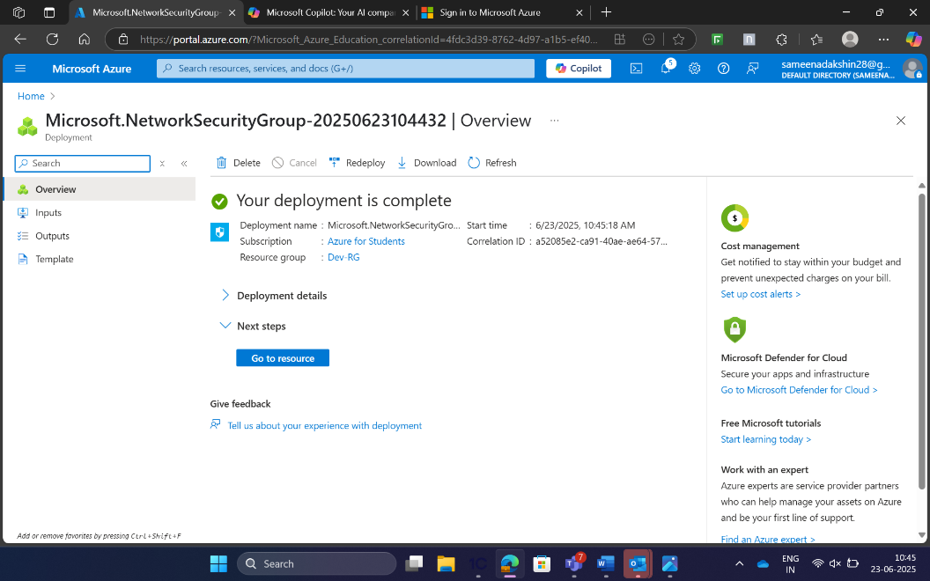

**Enabled  PORT:22 and PORT:80,**

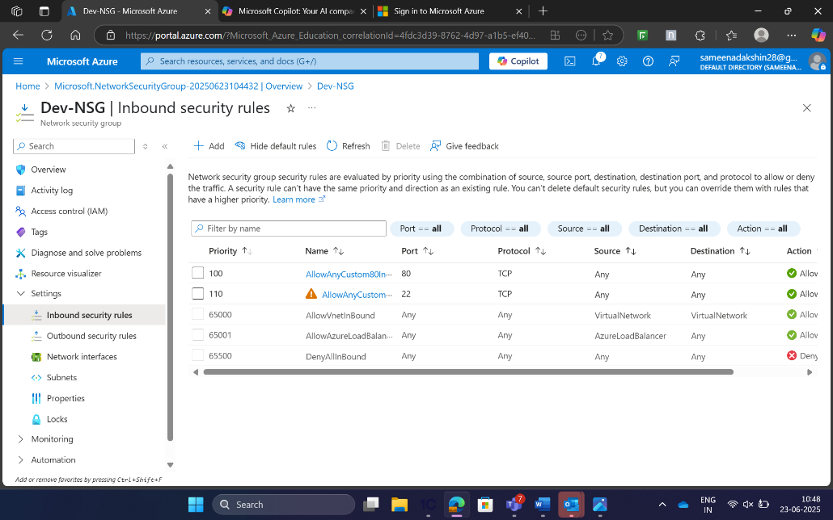

Step7::

Installing Docker on VM::

**VM is connected with the Bash shell**,

**Here ,we update the Vm ,and run the command like SUDO user and update**.

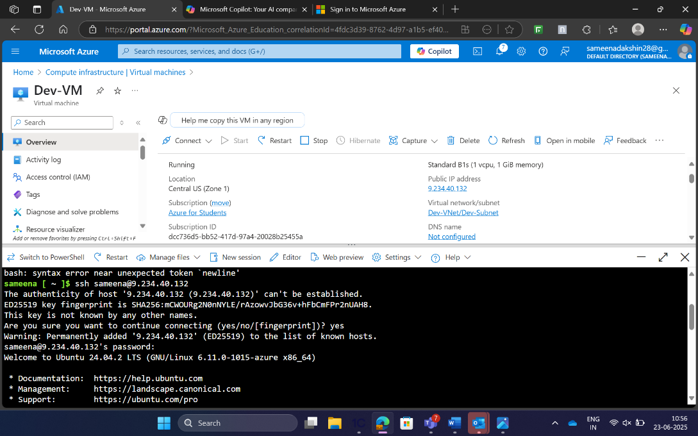

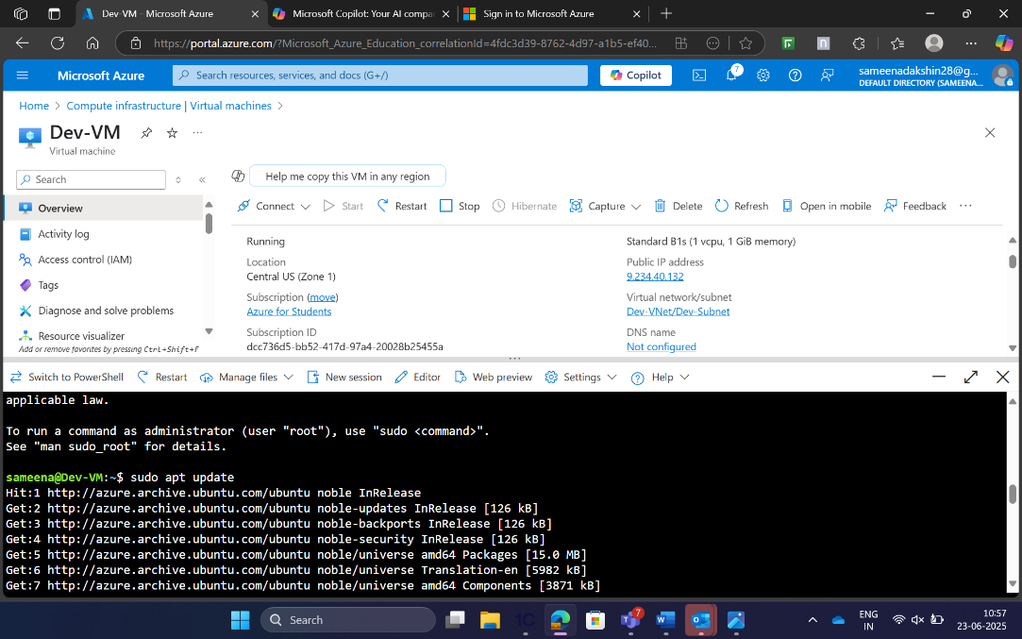

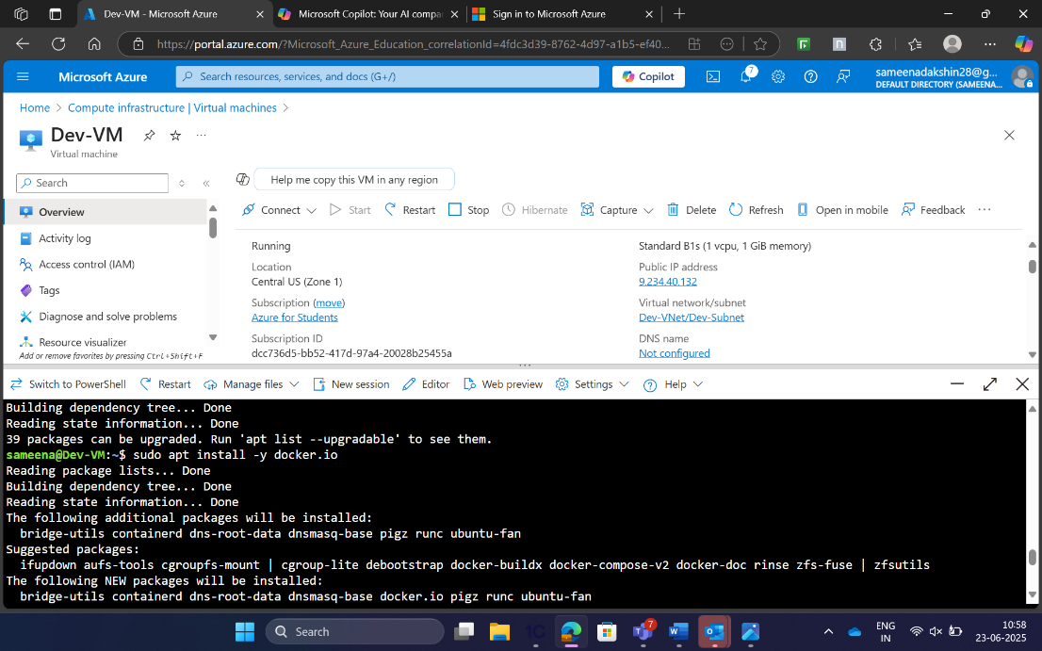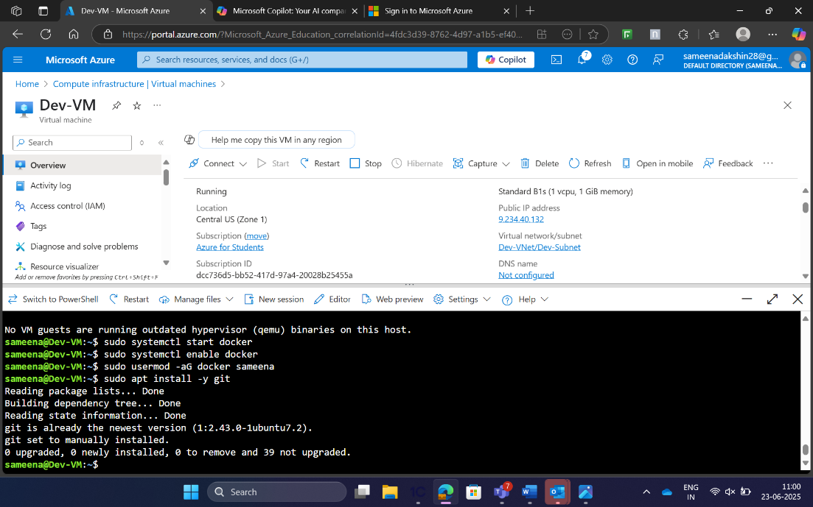

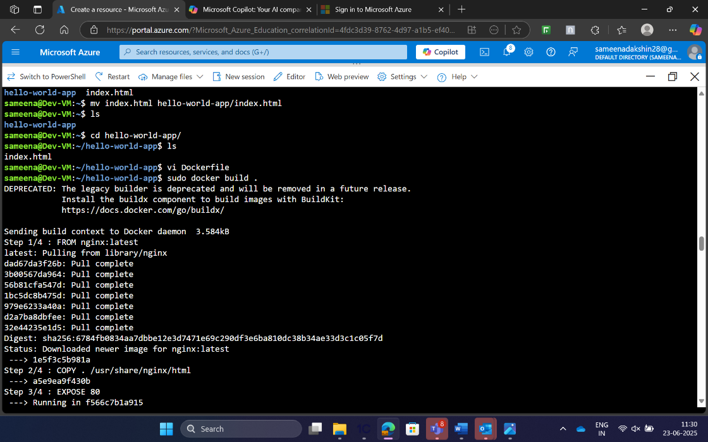

Step 8 and 9::

HTML and CSS web application, Writing Docker File

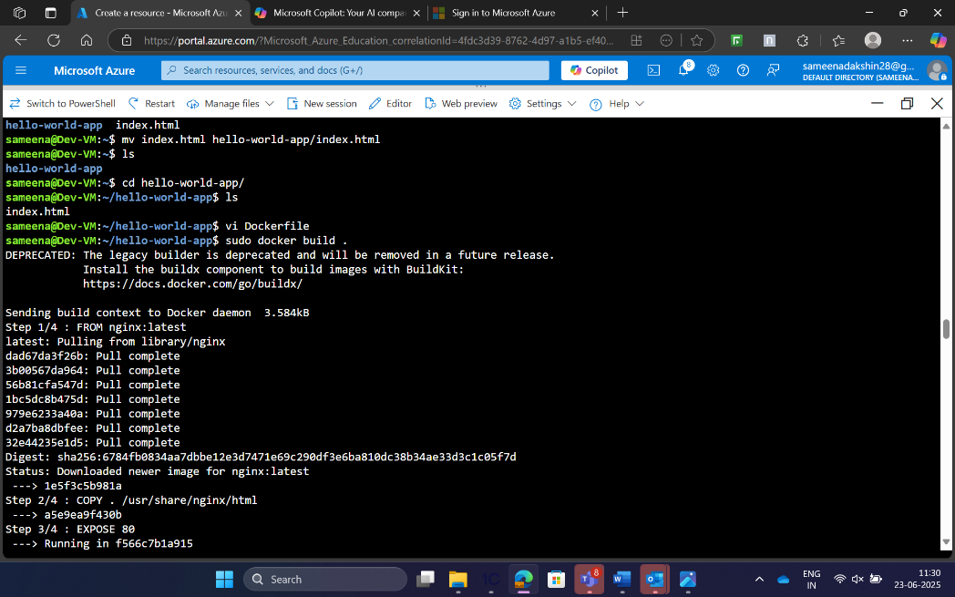

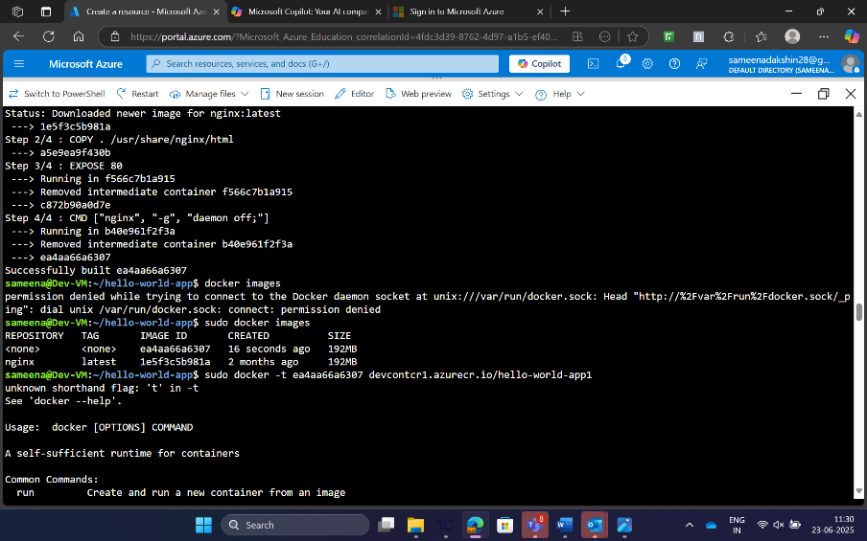

Installing az CLI

STEP 10:

Azure Container Registry:

• Name: devcontcr1

• Commands to Create and Push Docker Image:

az acr create \

--resource-group Dev-RG \

--name devcontcr1 \

--sku Basic

az acr login --name devcontcr1

docker tag hello-world-app devcontcr1.azurecr.io/hello-world-app:latest

docker push devcontcr1.azurecr.io/hello-world-app:latest

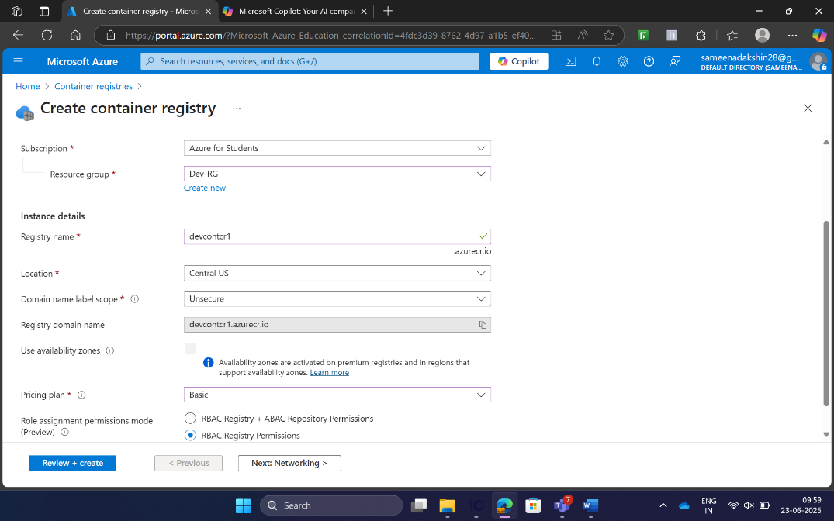

Container registry  
username:: devcontcr1

Password1:: 85Lif/PiX47GqypaFqTRxh1gEV+npbWL9NCDeSw3SE+ACRCPkepR

**ACR CREATED**

**To get the ACR connected with the vm ,we should run some prerequisites,**

* sudo apt-get install ca-certificates curl apt-transport-https lsb-release gnupg -y
* echo "deb [arch=amd64] [https://packages.microsoft.com/repos/azure-cli/ $(lsb_release -cs) main" | sudo tee /etc/apt/sources.list.d/azure-cli.list](https://packages.microsoft.com/repos/azure-cli/%E2%80%AF$(lsb_release%E2%80%AF-cs)%E2%80%AFmain%22%E2%80%AF%7C%E2%80%AFsudo%E2%80%AFtee%E2%80%AF/etc/apt/sources.list.d/azure-cli.list)
* sudo apt-get update
* sudo apt-get install azure-cli -y

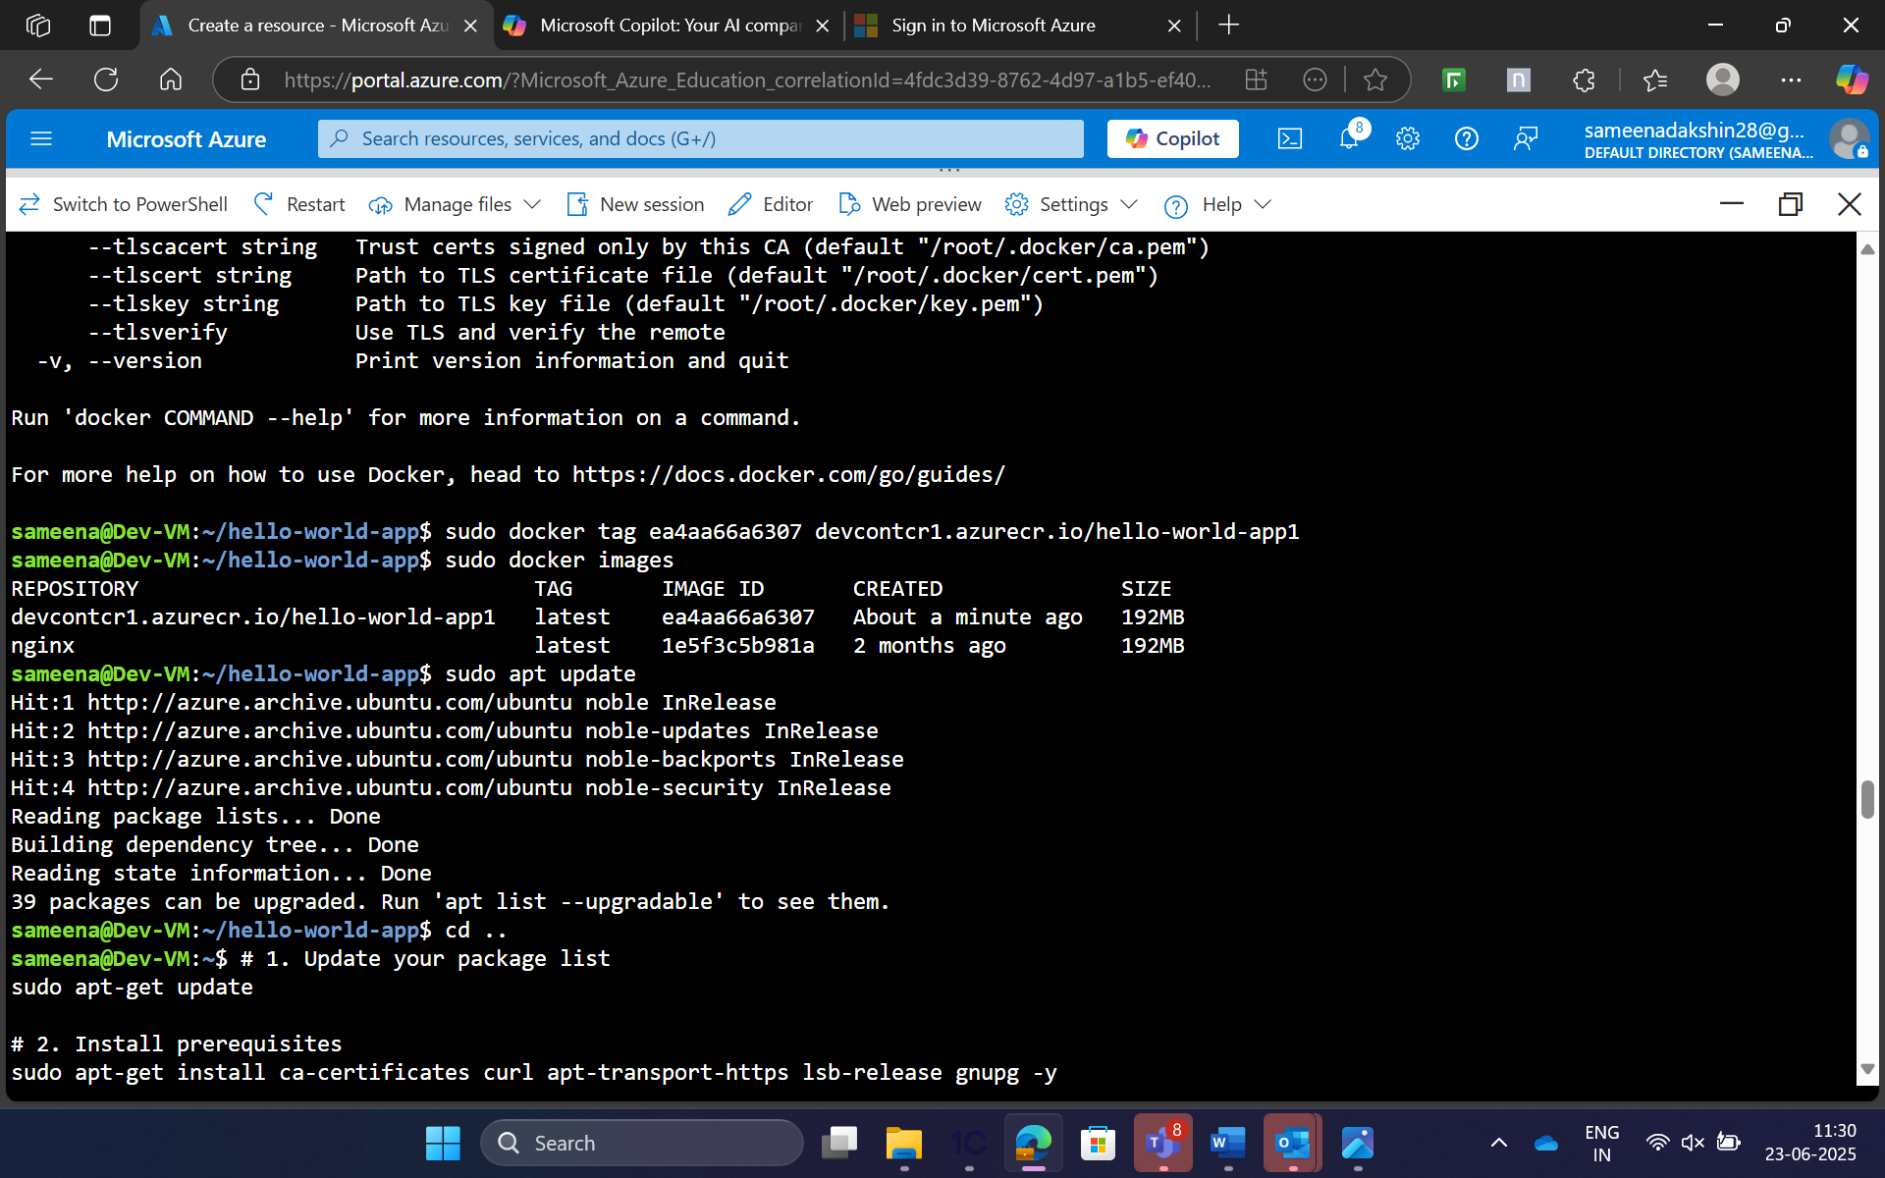

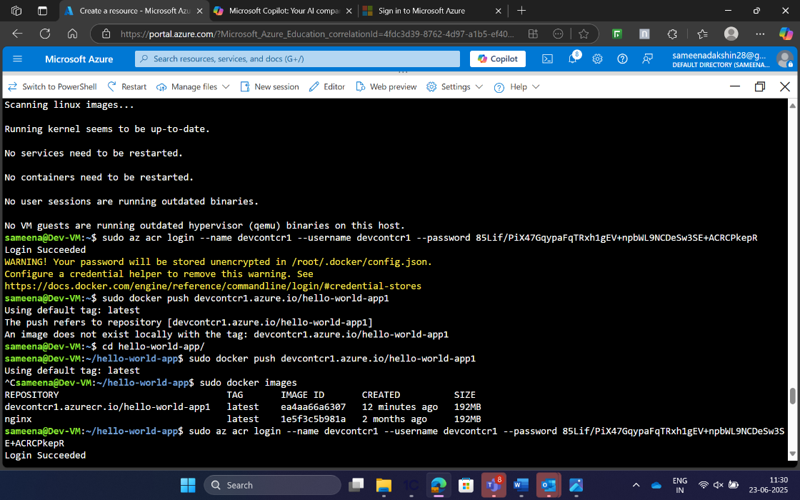 After that we need to push it to the docker push ,by providing the full iamge name .

**devcontcr.azurecr.io/hello-world-app**

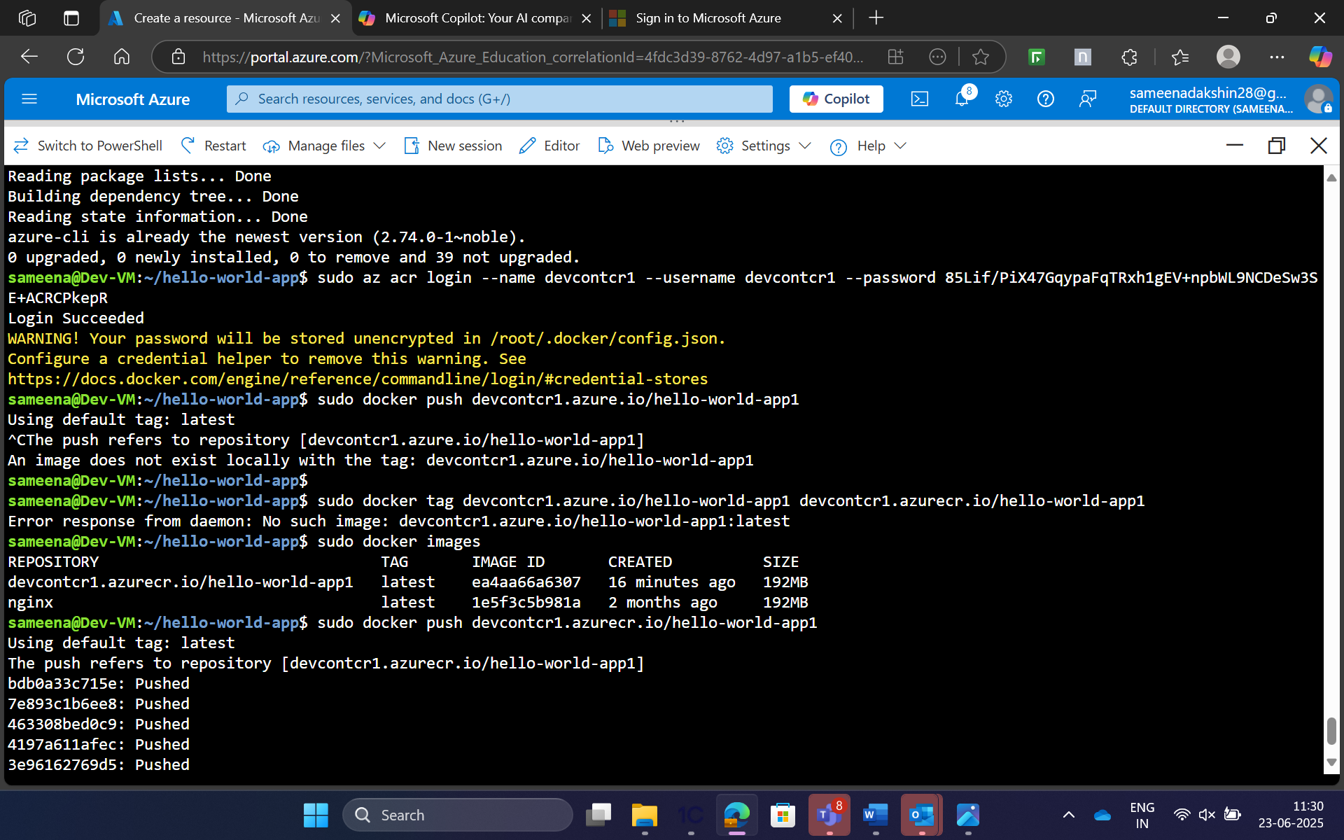

Step 11:

Azure K8s cluster

Under Kubernetes cluster, we need to create the resource group and the cluster details as **Dev/Test.**

We need to select the cluster region,as central Us.

After that we need to create the node pool,in which we need to create the pool name and choose the mode as **USER,**

**User Node Pools:**

* **Purpose:**

Dedicated to running your application workloads, allowing for customized configurations based on your application's specific requirements.

* **Characteristics:**

Can be scaled independently, and their configurations can be tailored to the needs of the applications they host (e.g., different VM sizes, operating systems, storage options).

**System Node Pools:**

* **Purpose:**

Designed to host essential Kubernetes system components that are vital for the cluster's operation.

* **Characteristics:**

Often have a fixed size and configuration, ensuring the stability of core cluster functionalities.

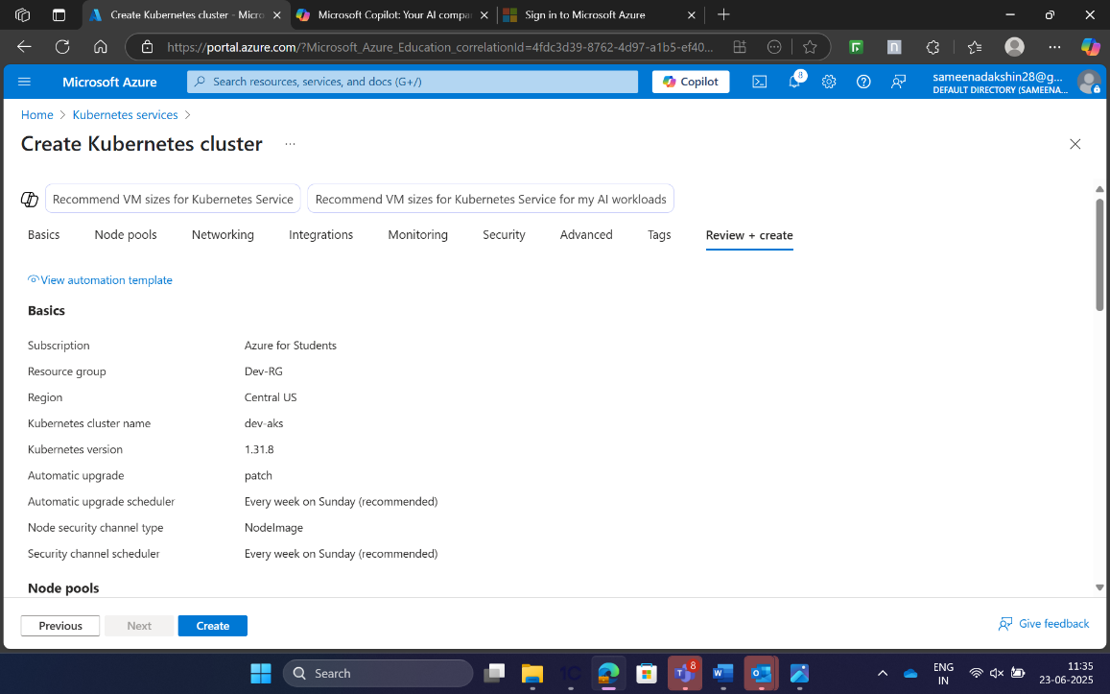

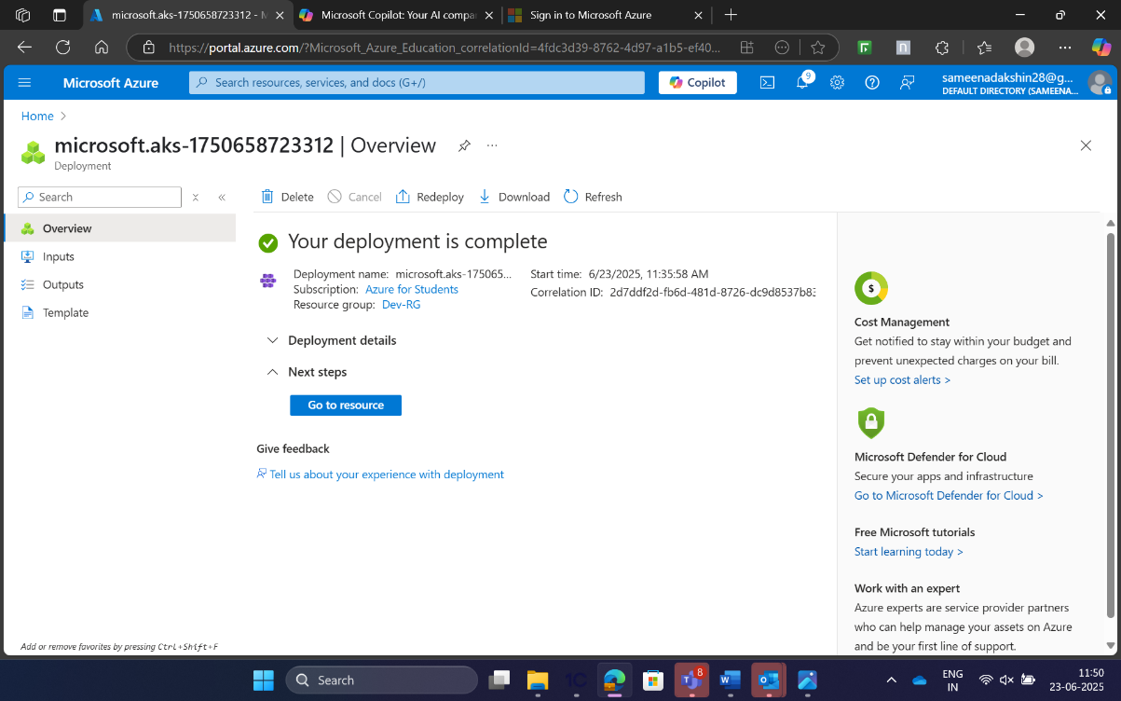

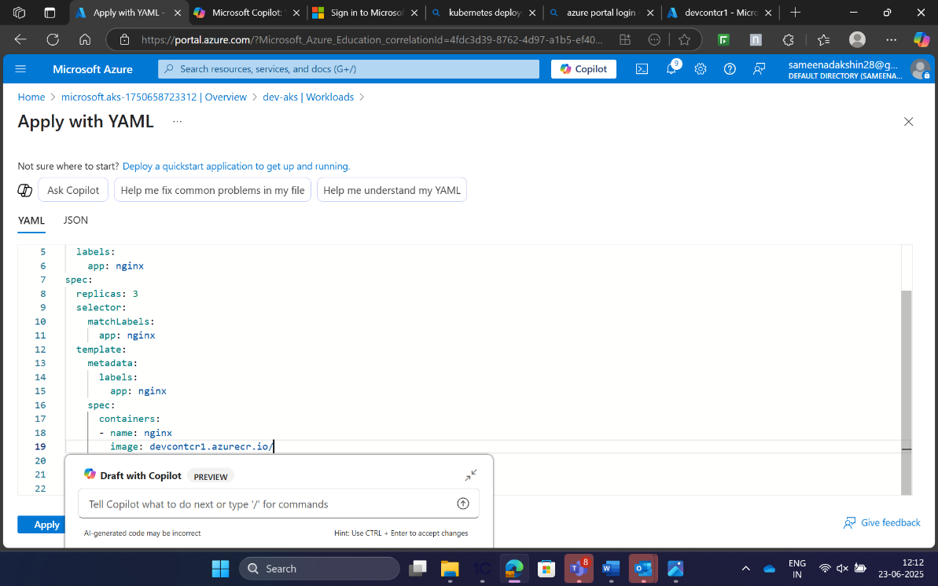

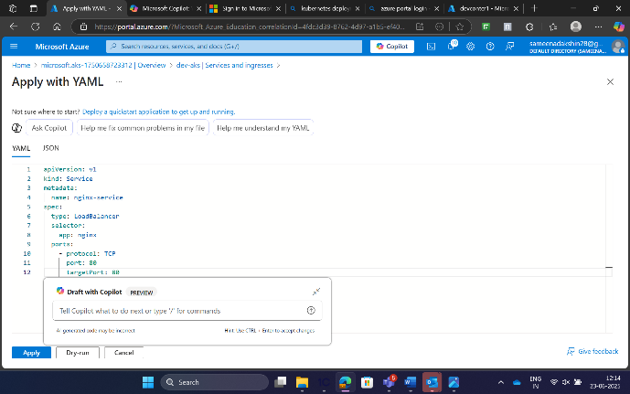

This is the **YAML file** for the deployment provided in the **WORKLOAD,deployment.yml**

**Nginx-deployment is created in the workload.**

Go to the **Services and ingress, and  create and add the yaml file and create a services type with loadbalancer.**

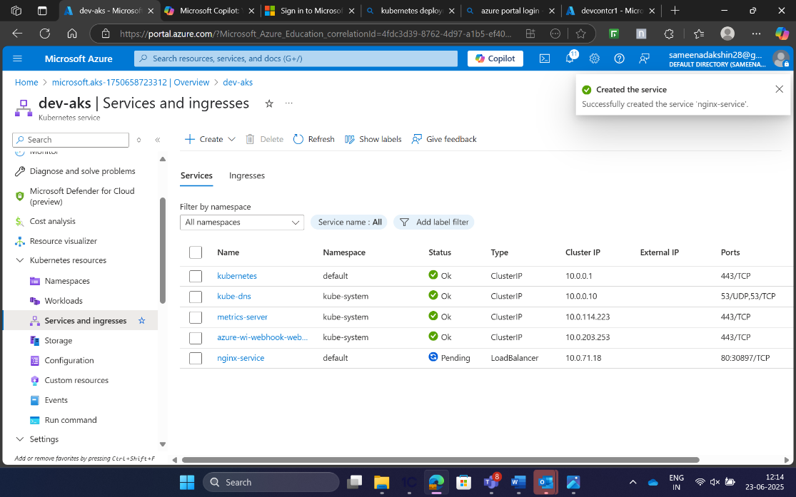

**In the Services and Ingress** ,there we have created the nginx-services,where  it generated the **External IP** address to access the HTML PAGE.

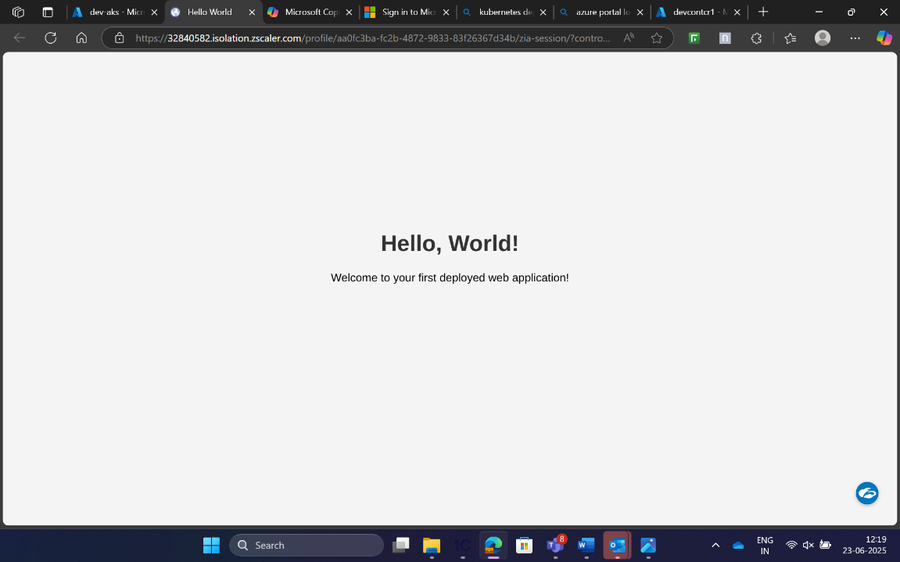

Deploymrnt.yaml and service.yaml::

apiVersion: apps/v1

kind: Deployment

metadata:

  name: hello-world-app

spec:

  replicas: 1

  selector:

    matchLabels:

      app: hello-world-app

  template:

    metadata:

      labels:

        app: hello-world-app

    spec:

      containers:

      - name: hello-world-app

        image: devenvironmentcr.azurecr.io/app:$(resources.pipeline.ci_build.runID)

        ports:

        - containerPort: 80

---

apiVersion: v1

kind: Service

metadata:

  name: hello-world-service

spec:

  type: LoadBalancer

  selector:

    app: hello-world-app

  ports:

    - protocol: TCP

      port: 80

      targetPort: 80

**PIPELINE INTEGRATION (CI/CD)::**

**Clone Repository :**

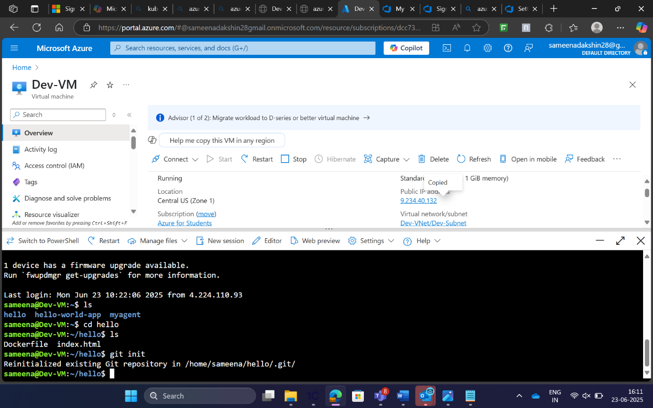

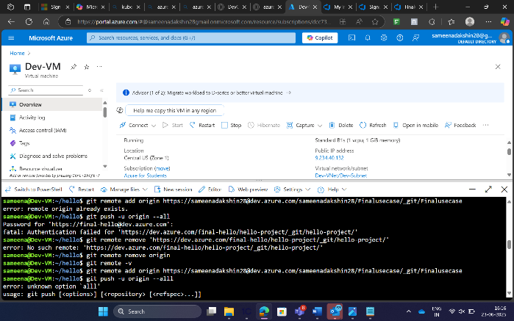

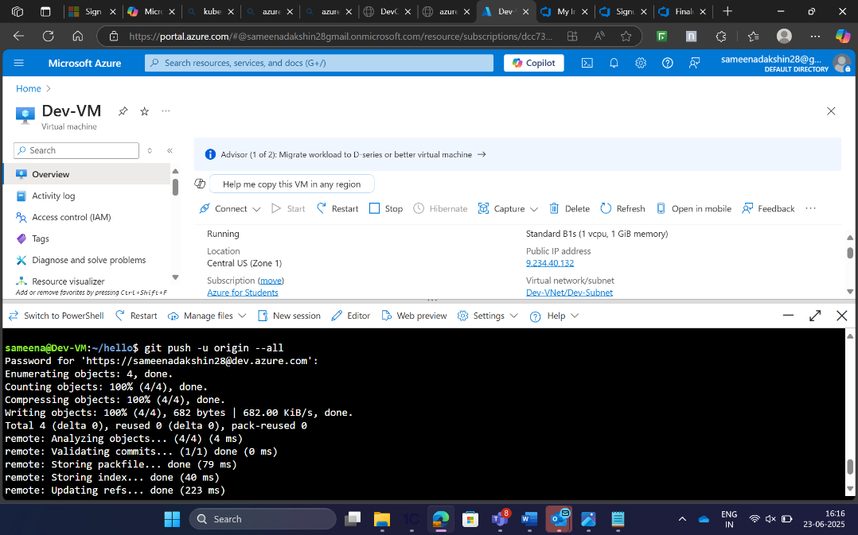

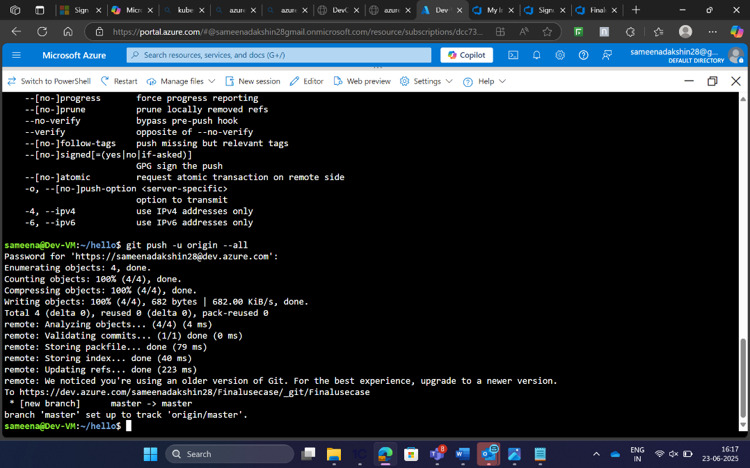

**SELF HOSTED AGENT CREATION:**

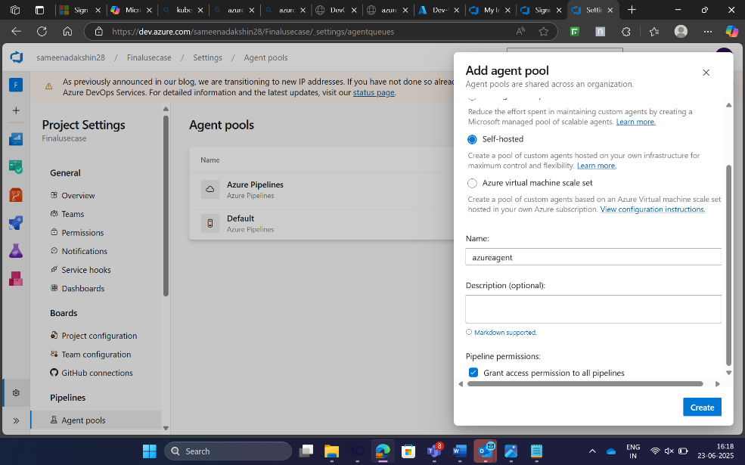

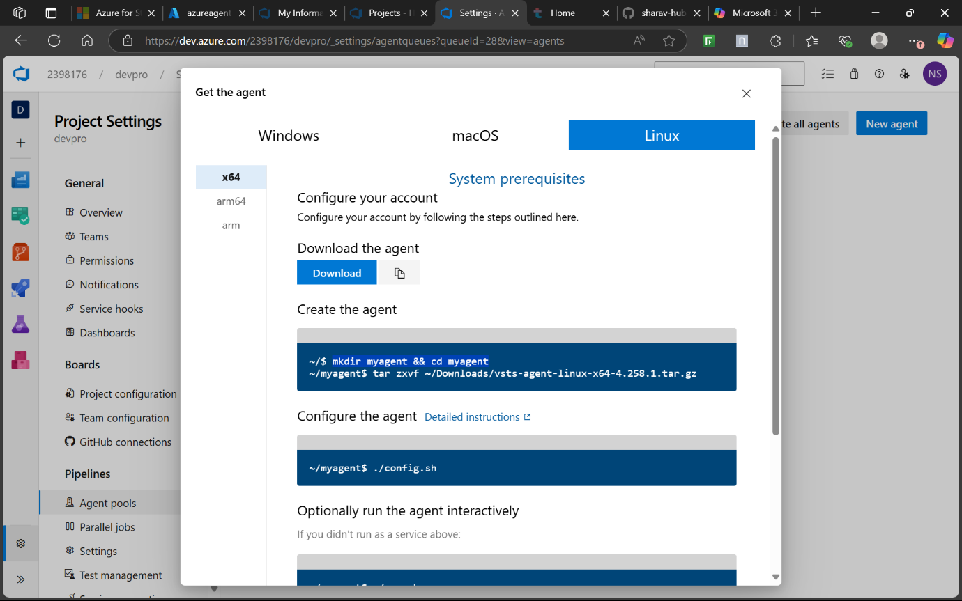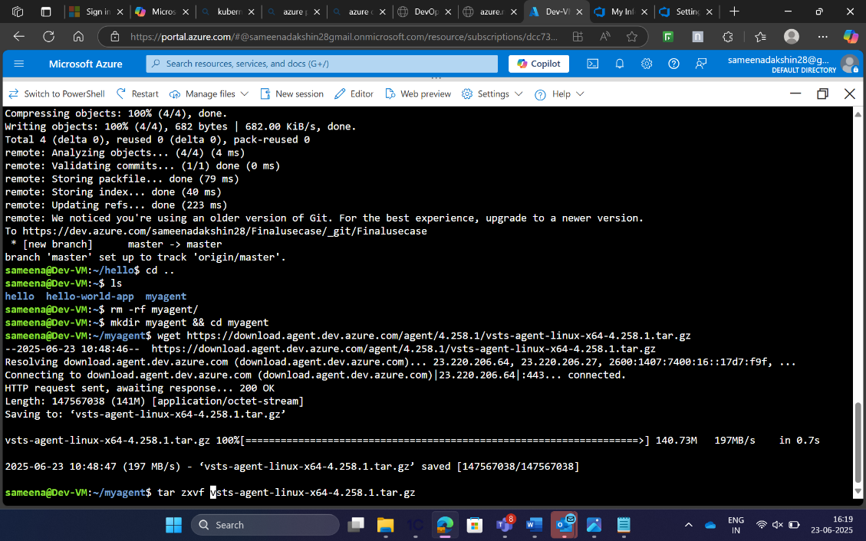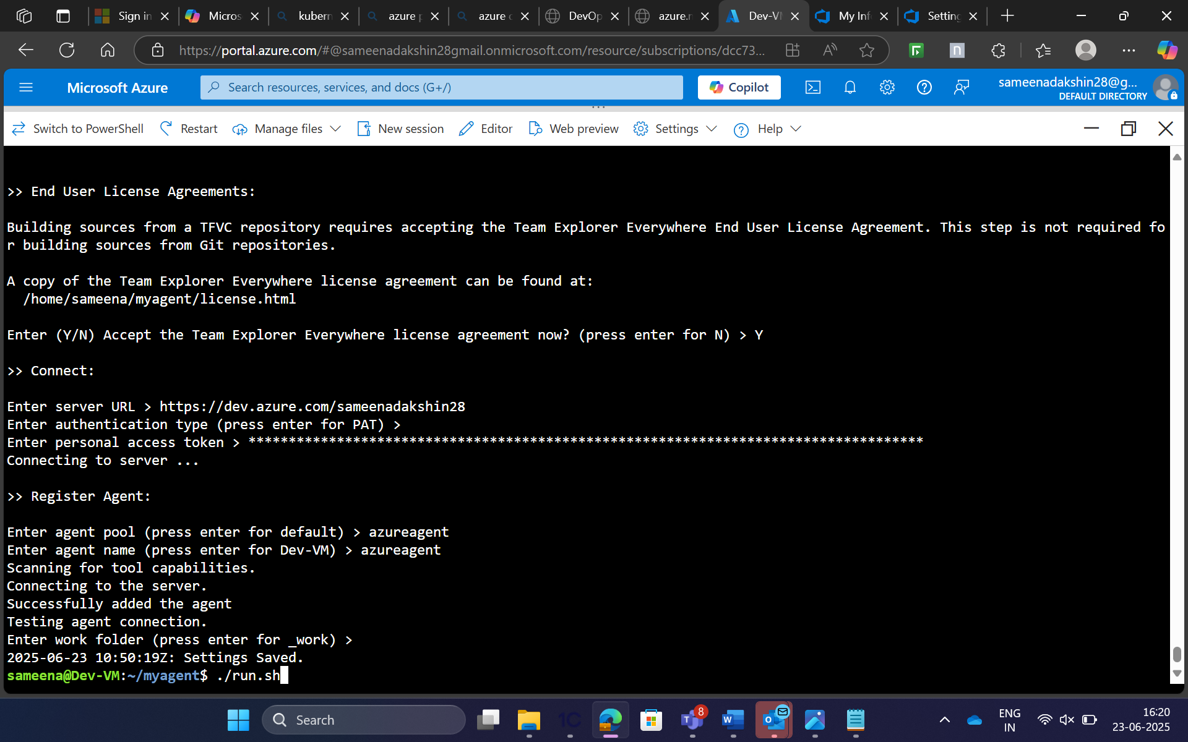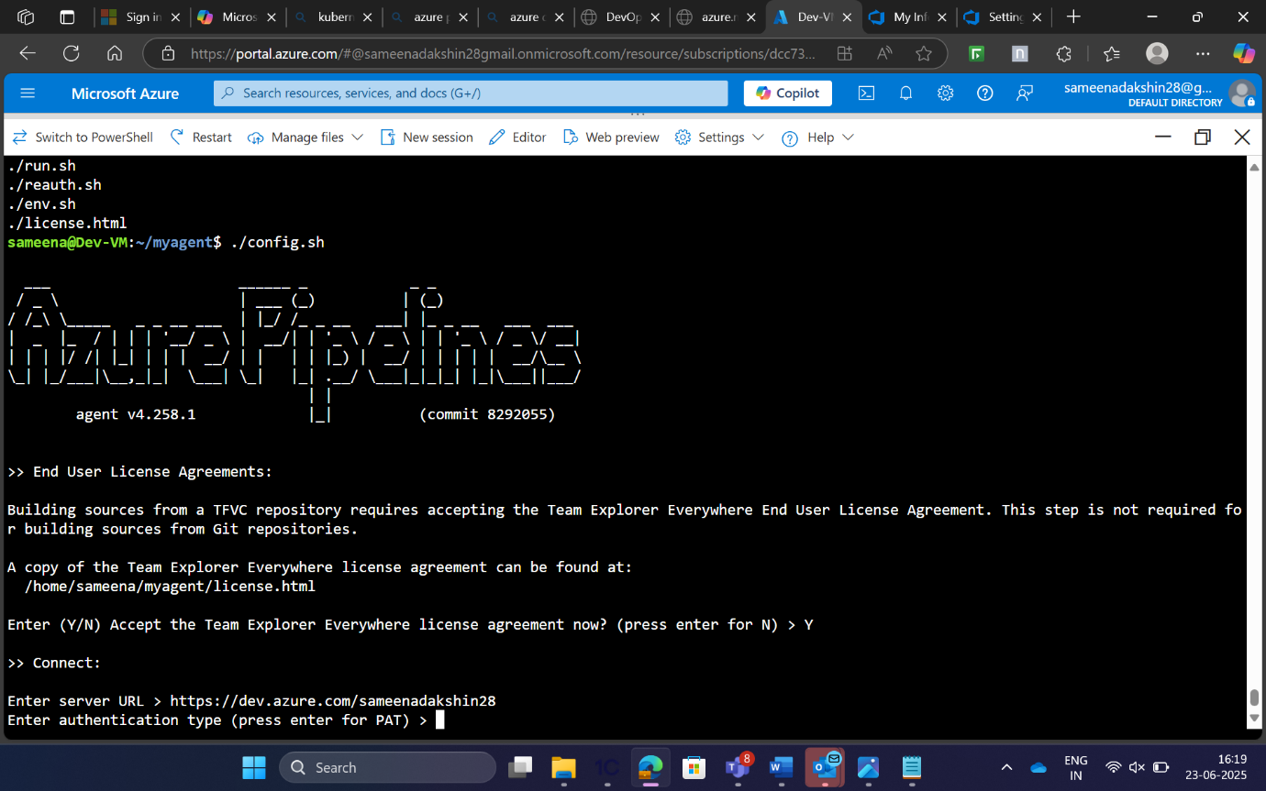

CI Pipeline:

I created new pipeline and added task of command line script where I pushed built image to ACR,publish build artifact and copy files to stagingartifact.  
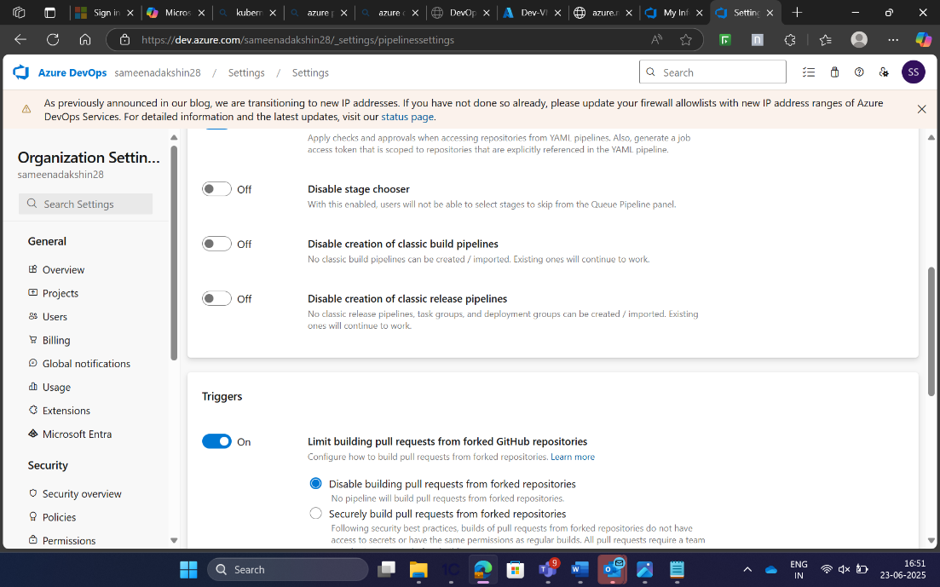 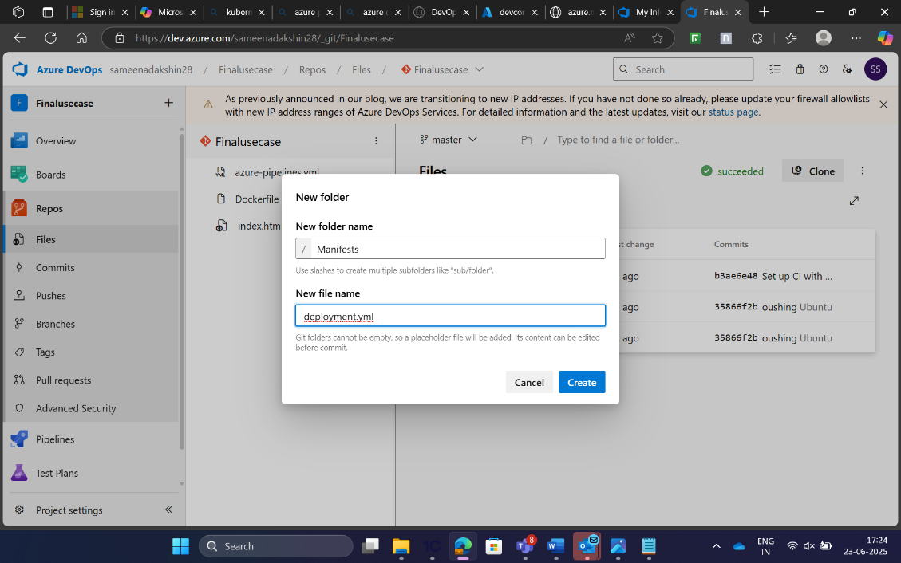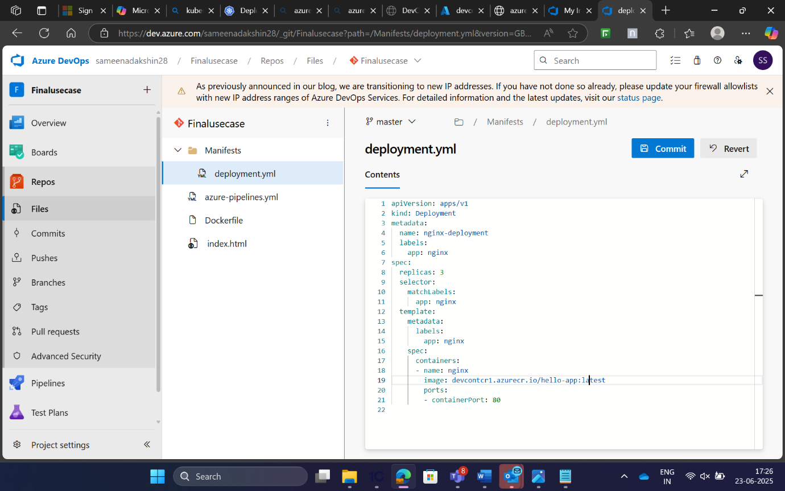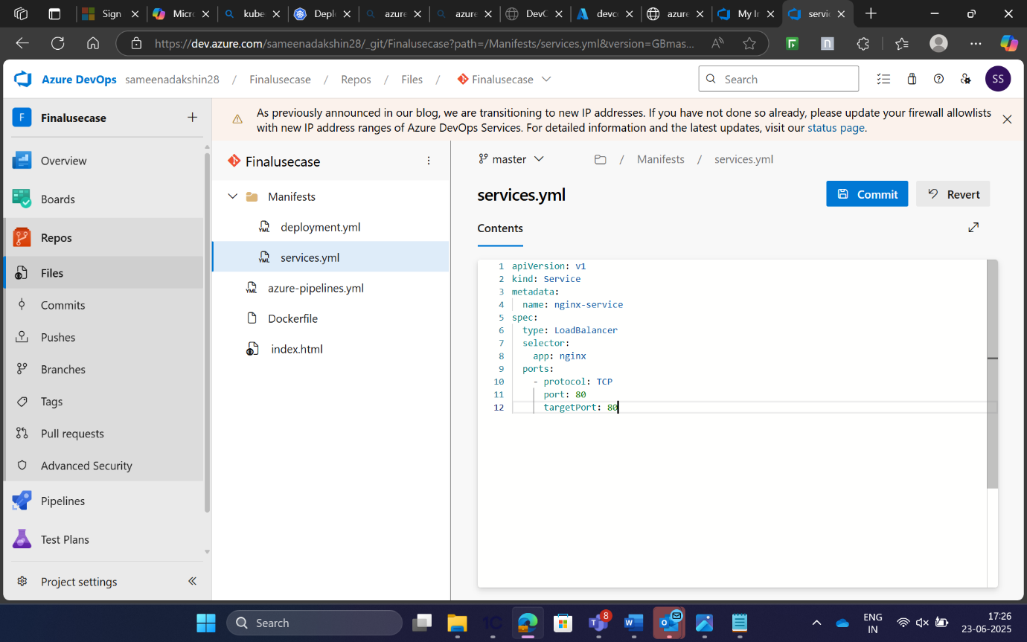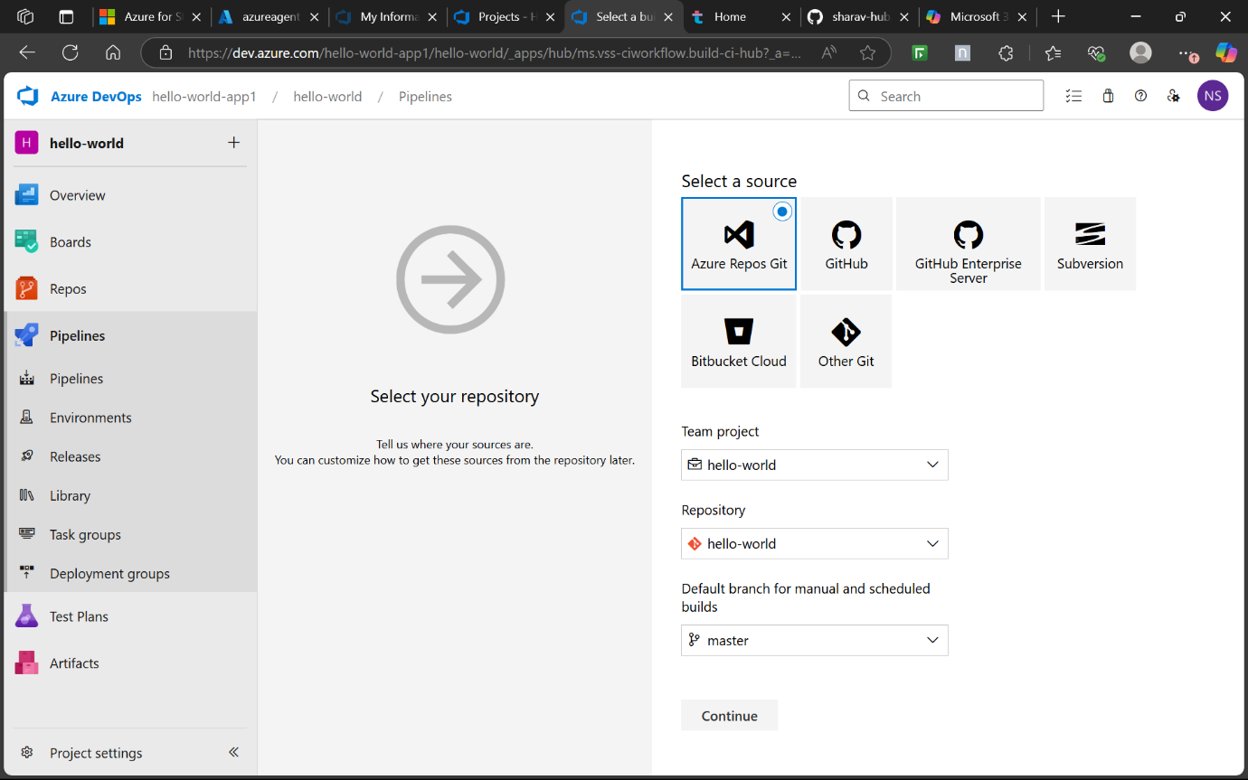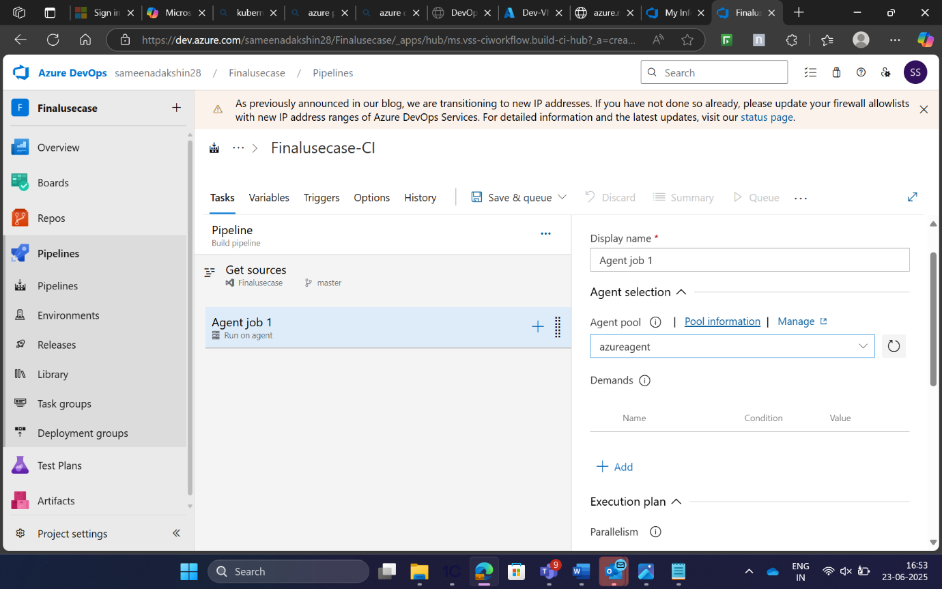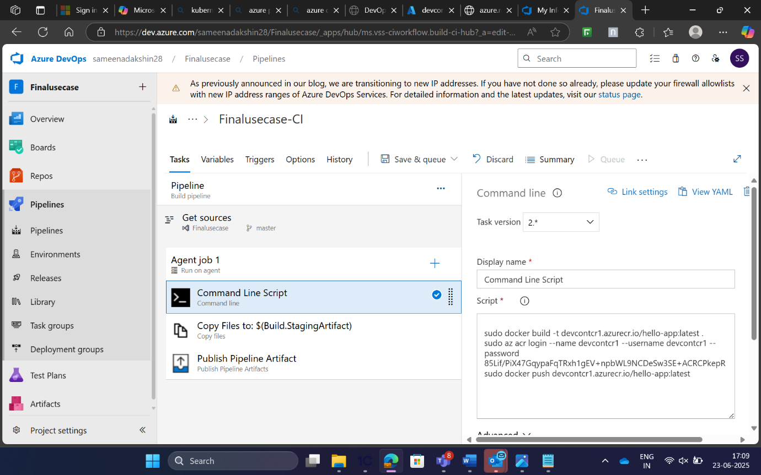 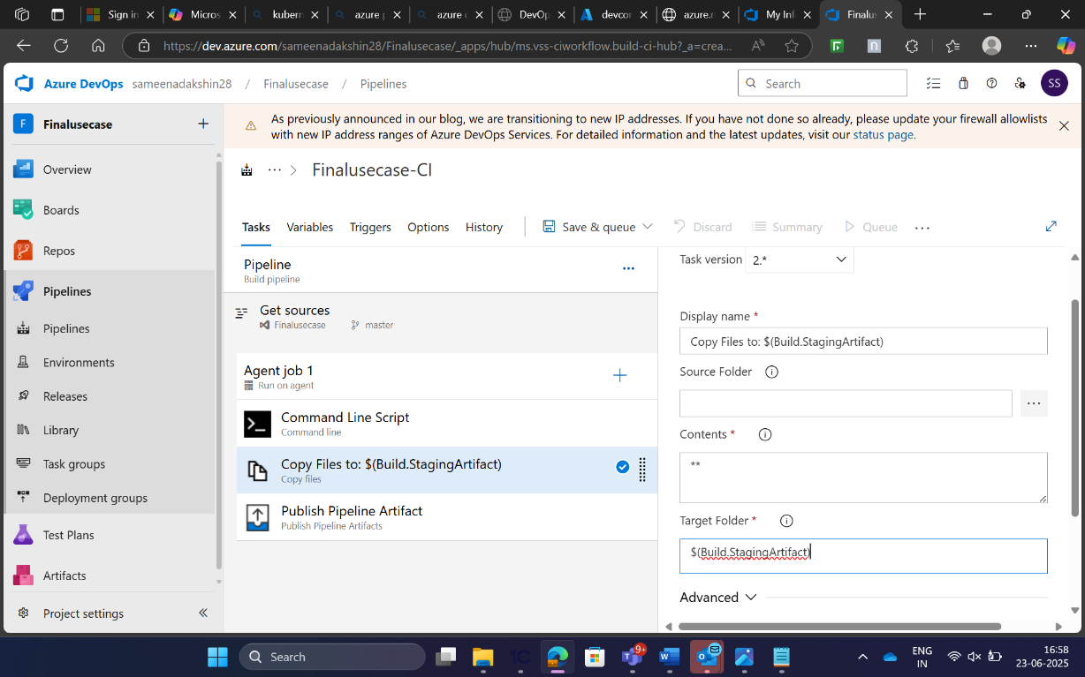

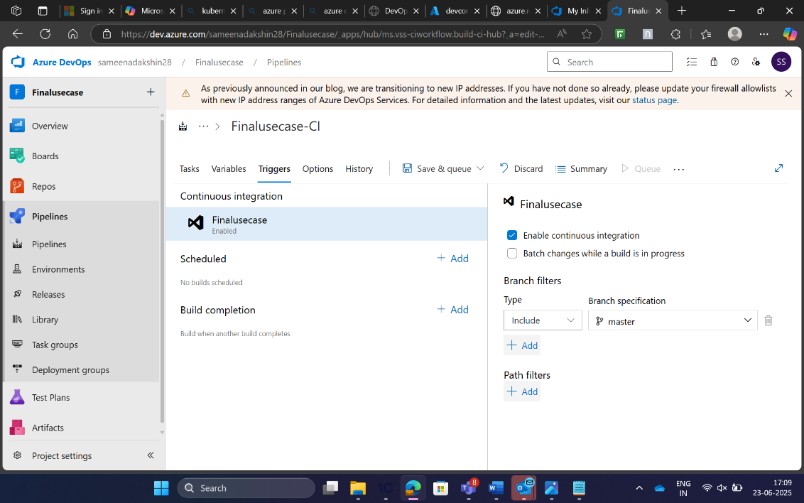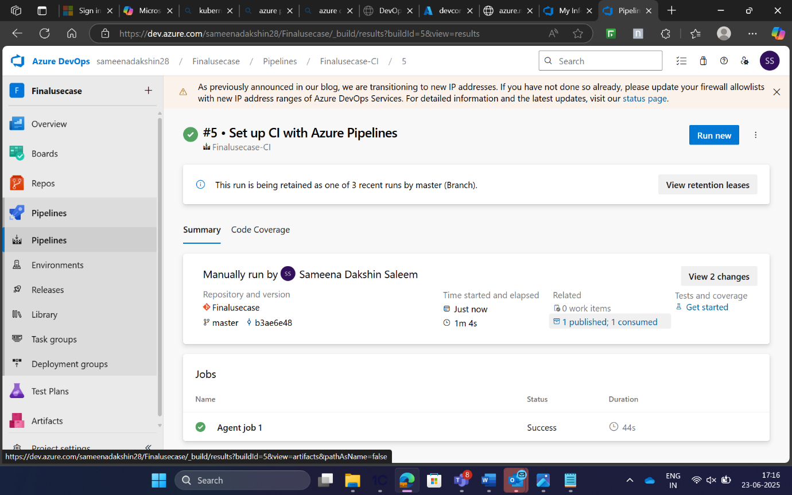

CD Pipeline::

* **CD (Release Pipeline):**
* Pull the Docker image from ACR.
* Deploy the application to Azure Kubernetes Service (AKS).

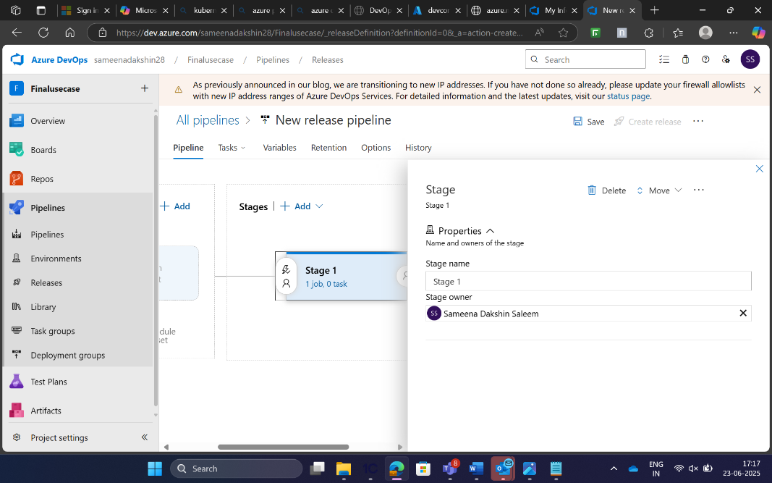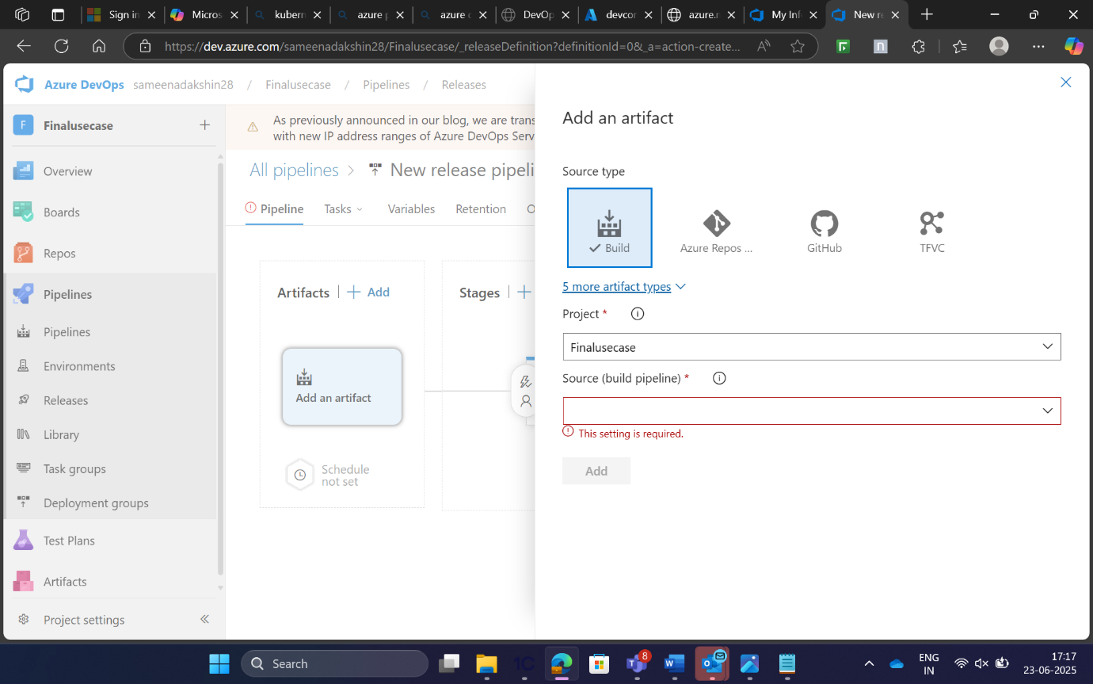

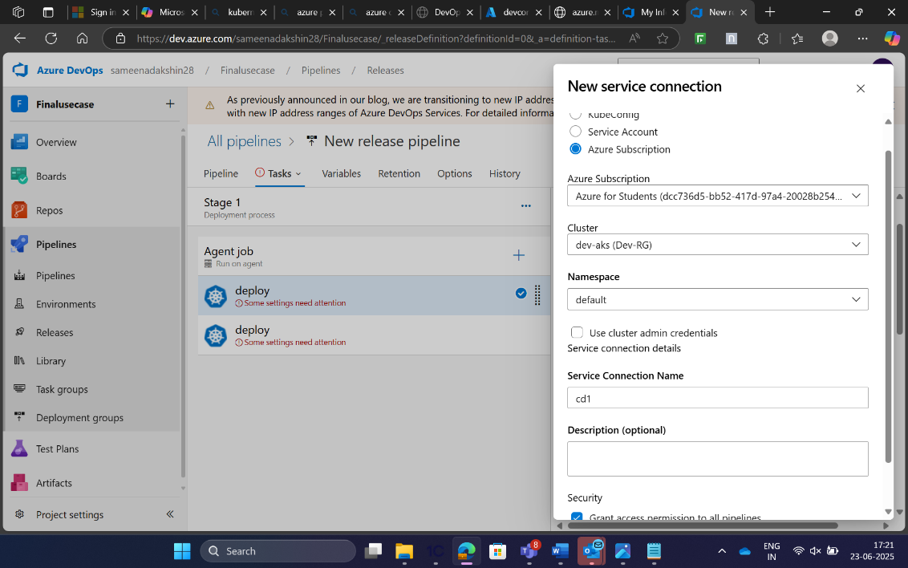

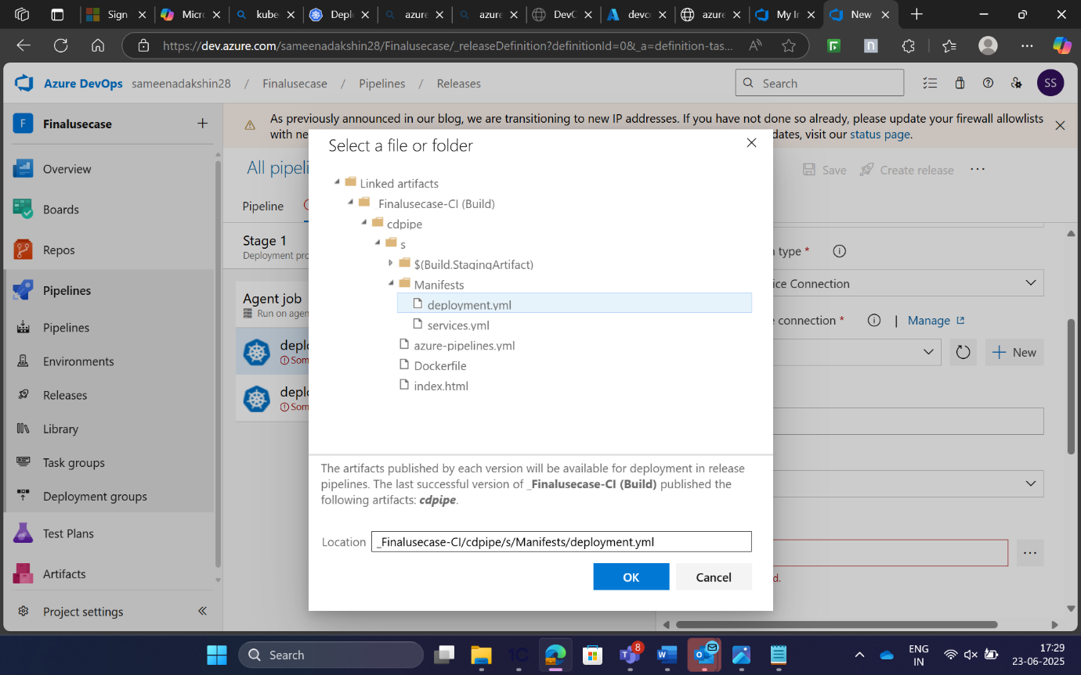

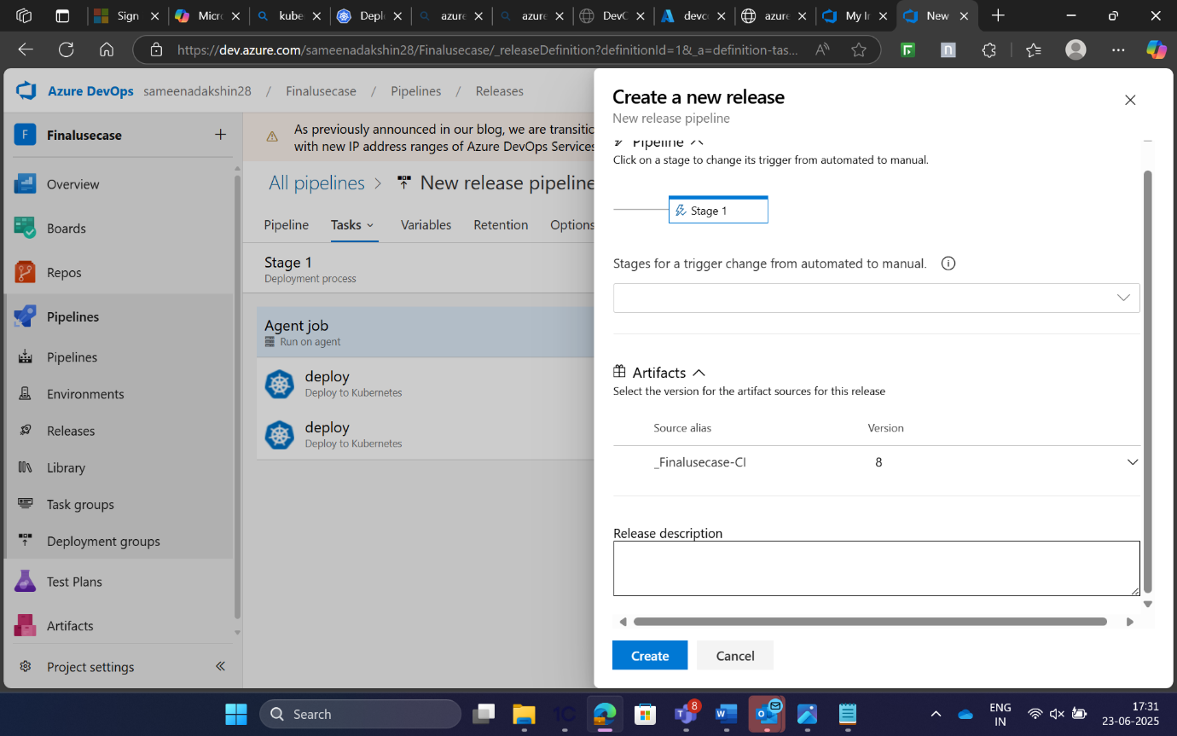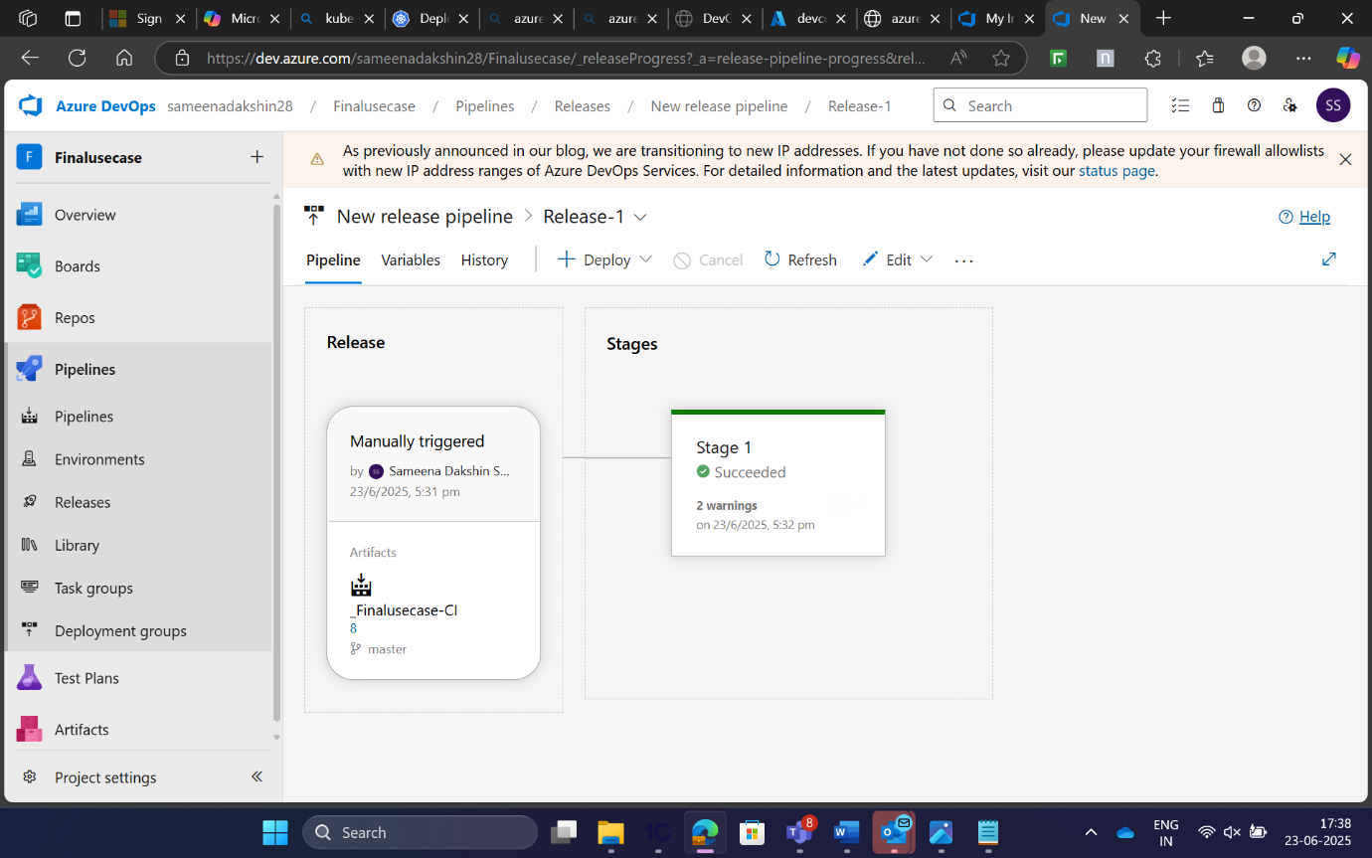

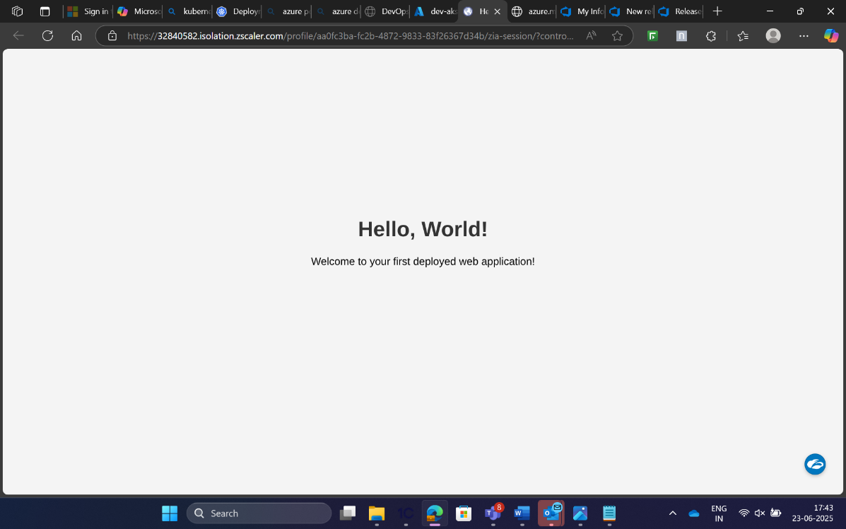

HEALTH CHECKS::

Health-check.ps1::

# health-check.ps1

# Kubernetes Cluster Health Check Script

function Check-Nodes {

Write-Host "Checking Kubernetes Nodes..."

$nodes = kubectl get nodes --no-headers | ForEach-Object {

$fields = $_ -split '\s+'

[PSCustomObject]@{

NodeName = $fields[0]

Status = $fields[1]

}

}

$allHealthy = $true

foreach ($node in $nodes) {

if ($node.Status -ne "Ready") {

Write-Error "Node $($node.NodeName) is not healthy. Status: $($node.Status)"

$allHealthy = $false

} else {

Write-Host "Node $($node.NodeName) is healthy."

}

}

if (-not $allHealthy) {

exit 1

}

}

function Check-Pods {

Write-Host "Checking Kubernetes Pods..."

$pods = kubectl get pods --all-namespaces --no-headers | ForEach-Object {

$fields = $_ -split '\s+'

[PSCustomObject]@{

Namespace = $fields[0]

PodName = $fields[1]

Status = $fields[2]

}

}

$allHealthy = $true

foreach ($pod in $pods) {

if ($pod.Status -notin @("Running", "Completed")) {

Write-Error "Pod $($pod.PodName) in namespace $($pod.Namespace) is not healthy. Status: $($pod.Status)"

$allHealthy = $false

} else {

Write-Host "Pod $($pod.PodName) in namespace $($pod.Namespace) is healthy."

}

}

if (-not $allHealthy) {

exit 1

}

}

Check-Nodes

Check-Pods

Write-Host "All Kubernetes components are healthy."

exit 0

and change to be added in pipelines-1.yml::

- checkout: self  
- task: PowerShell@2

displayName: 'Kubernetes Cluster Health Check'

inputs:

targetType: 'filePath'

filePath: 'health-check.ps1'

pwsh: true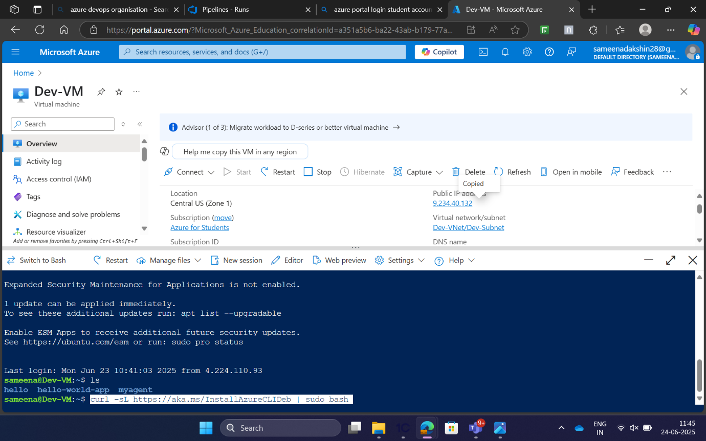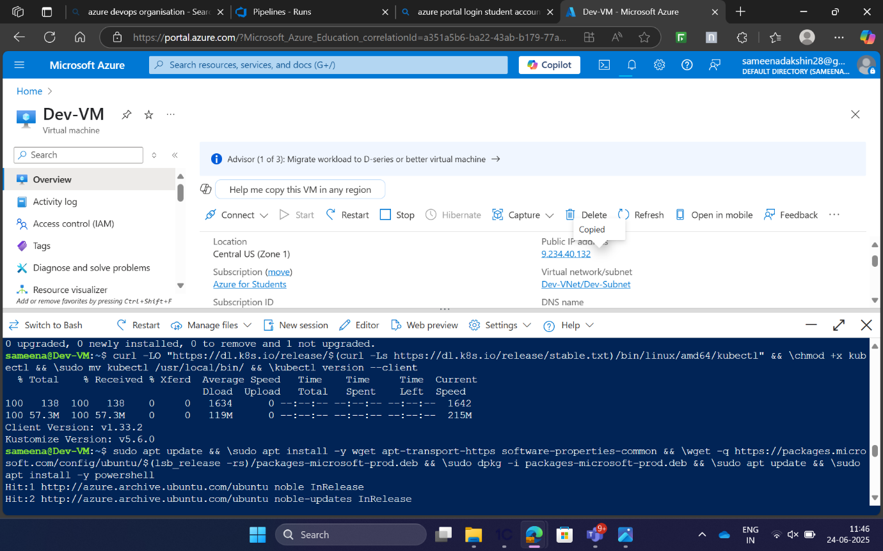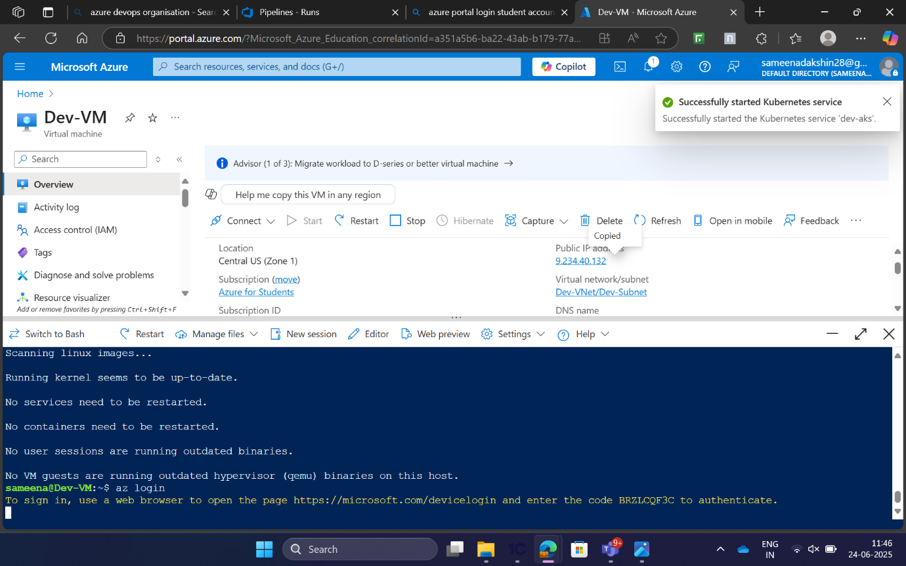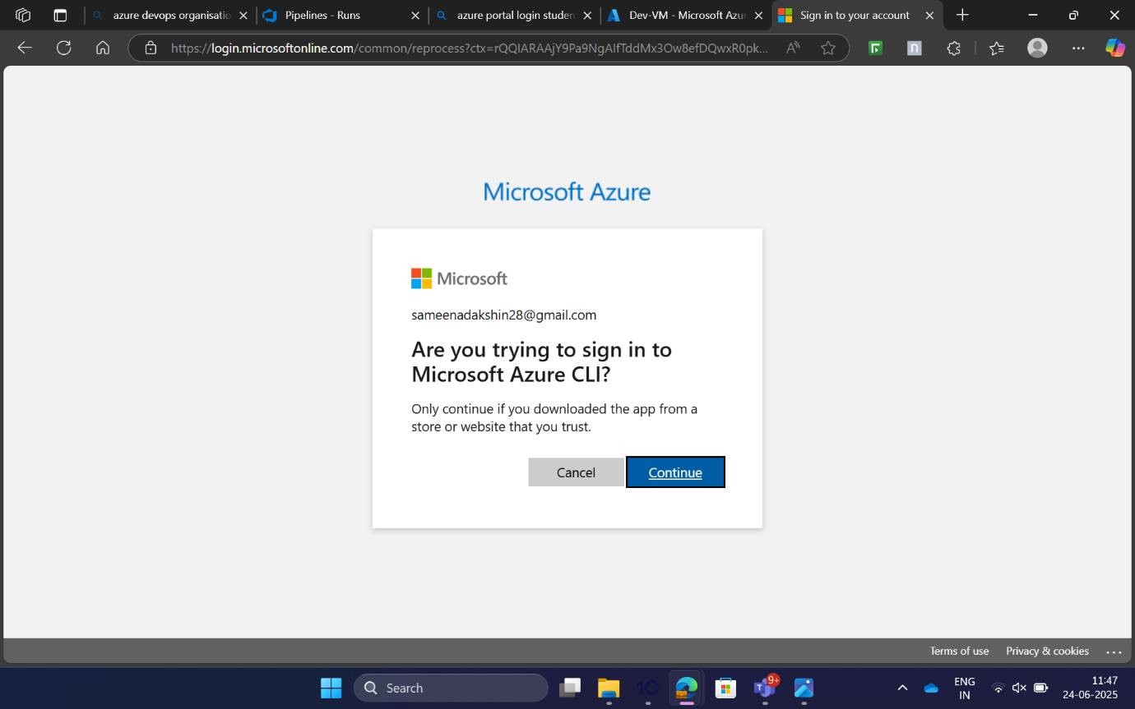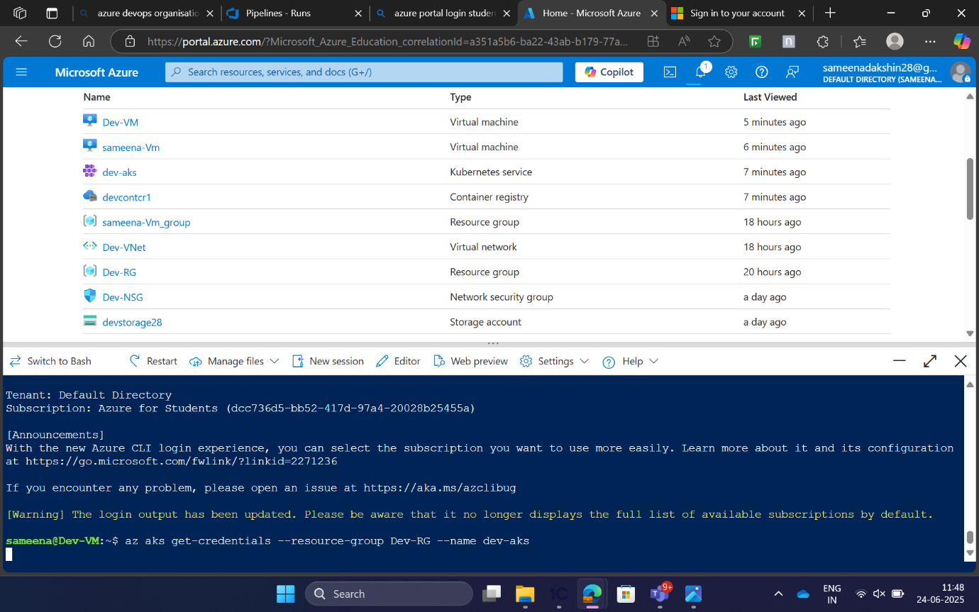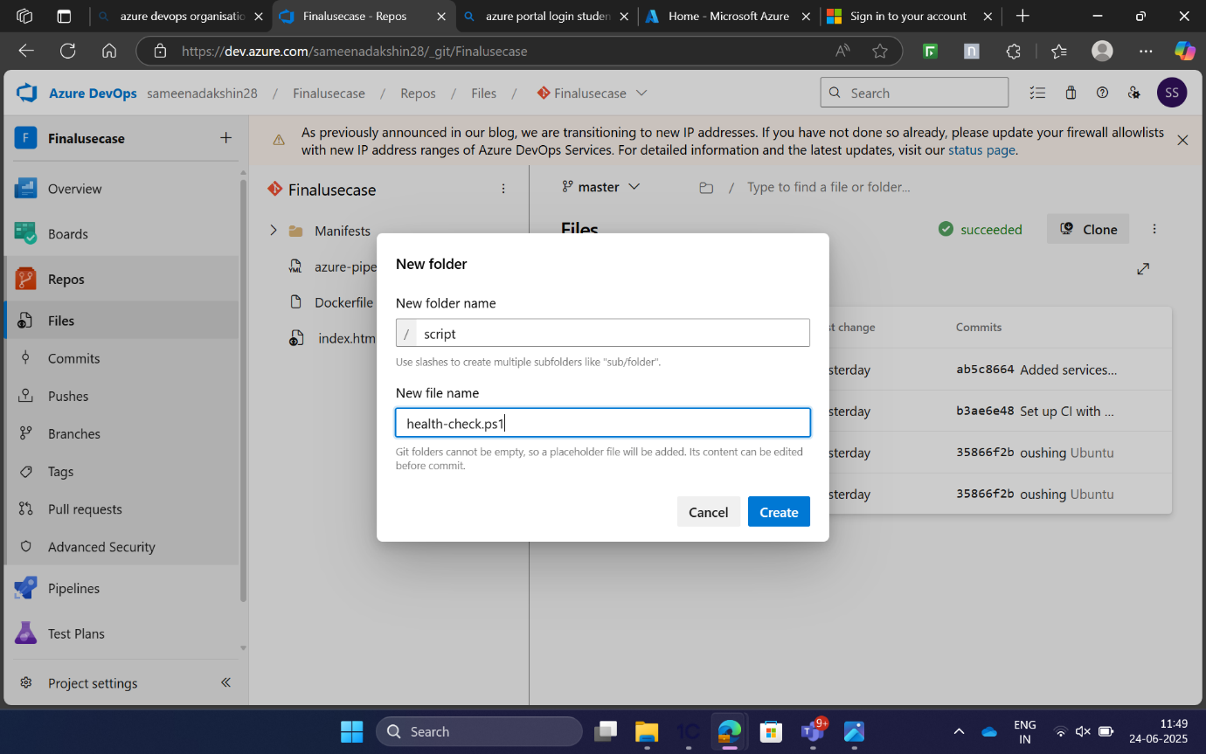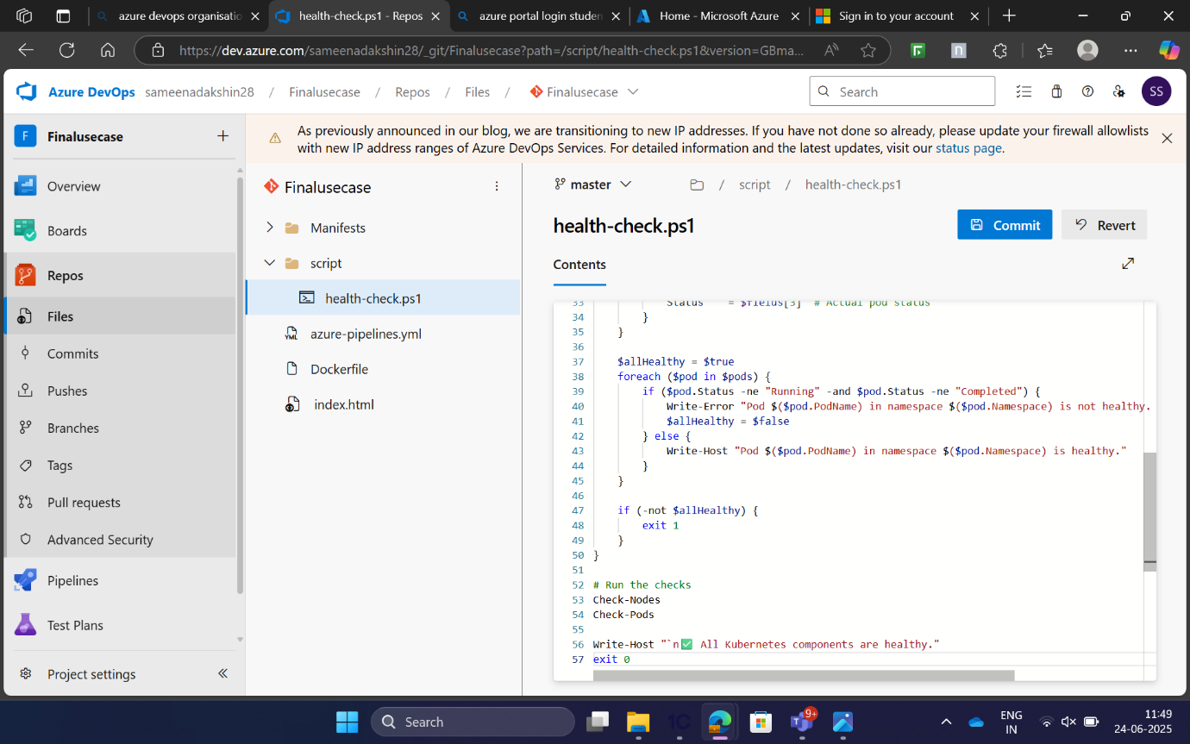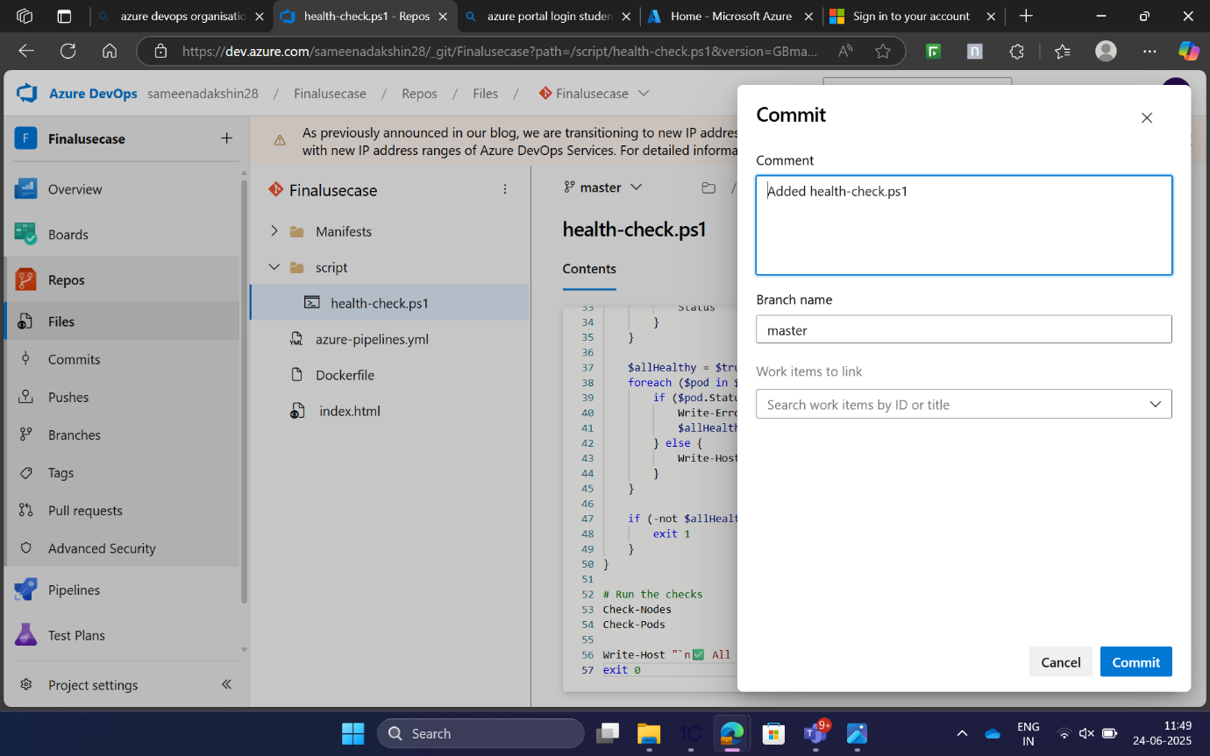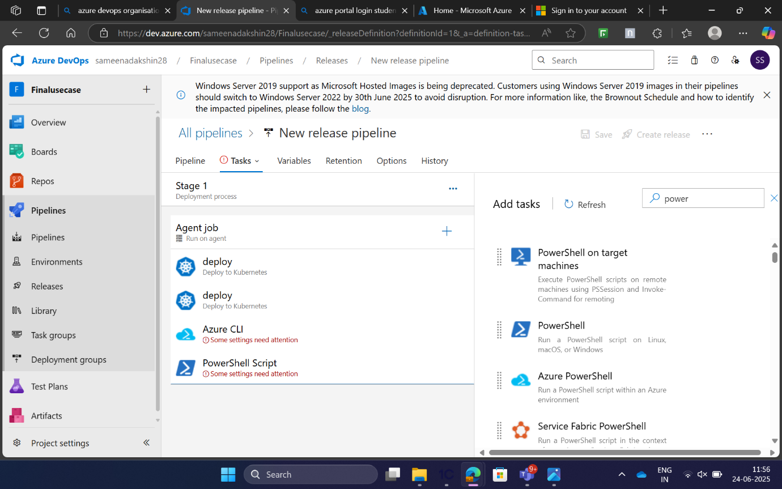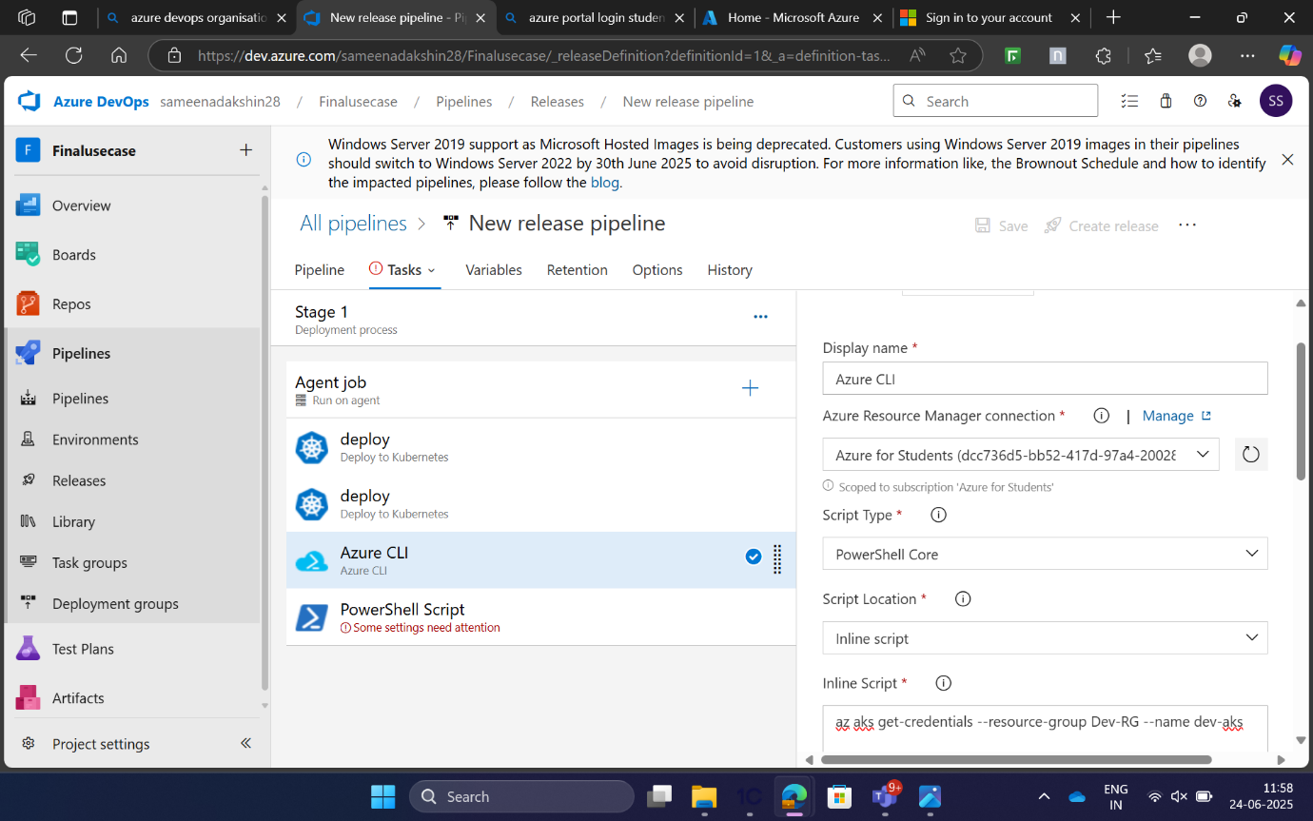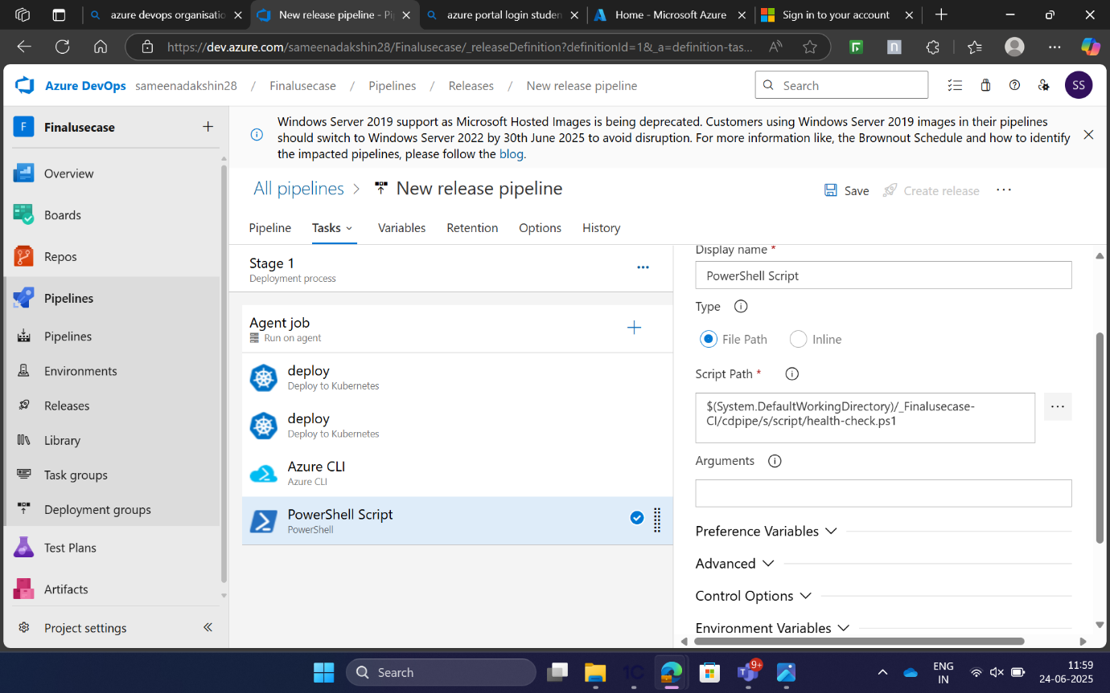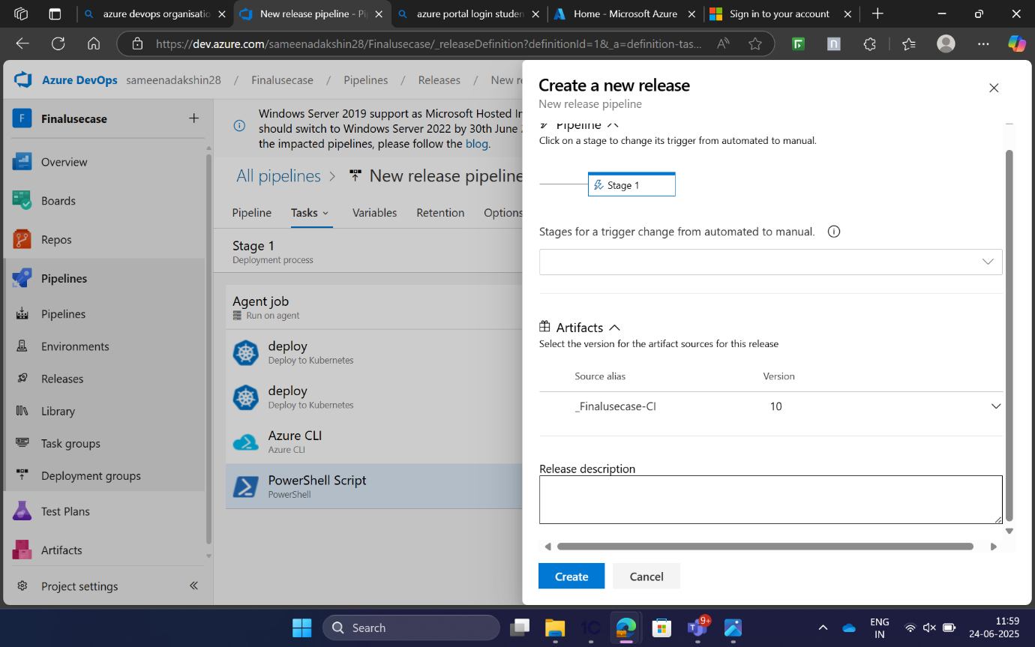

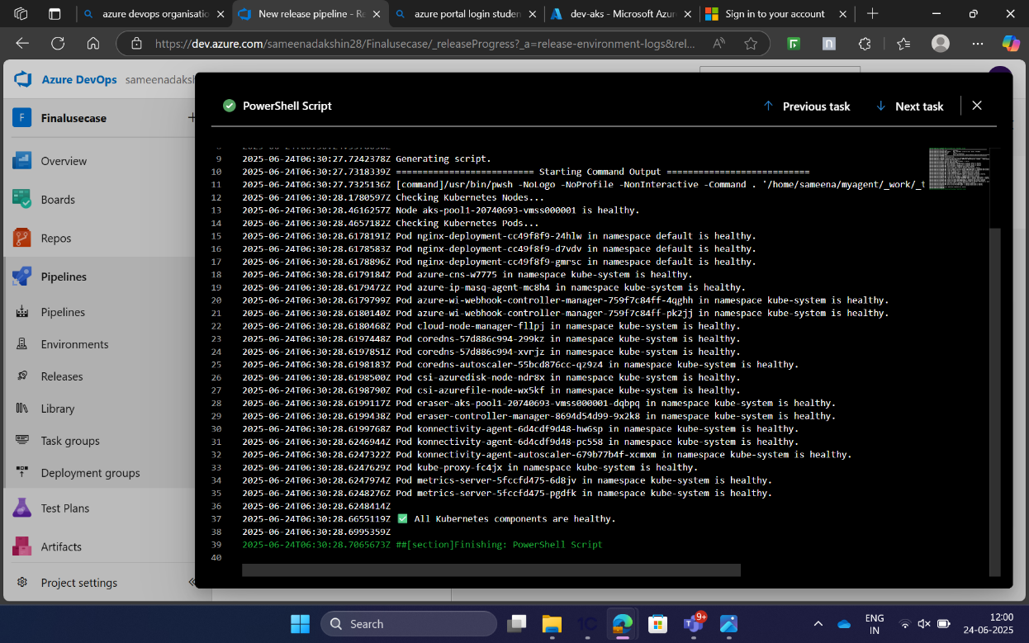**Conclusion**: This projects successfully demonstrates a complete CI/CD pipeline implementation using Azure DevOps, Docker, Azure Container Registry (ACR), and Azure Kubernetes Service (AKS). Starting from building a static "Hello World" web application, I containerized it using Docker, pushed the image to ACR, and deployed it on AKS using Kubernetes manifests — all automated through Azure DevOps Classic Pipelines.

Through this end-to-end setup, I gained hands-on experience with:

Containerization and image management,

 CI/CD automation, Kubernetes deployment workflows, Azure cloud services integration.